
Software Engineering Department
ORT Braude College

Smart Visit Card
Inaudible Information Transfer between Android Based Devices

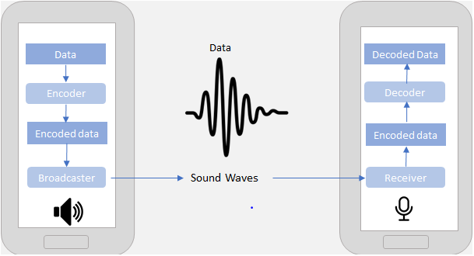

Authors:
Taimor Fares 308137355
Fares Jaraisy 208451682

Supervisors:
Dr. Dan Lamberg
Dr. Elena Ravve
Table of Content

1. INTRODUCTION 3
2. BACKGROUND AND RELATED WORK 5
3. OUR APPROACH - ULTRASONIC SOUND BASED DATA TRANSFER 15
4. INFORMATION TRANSFER WITH SMARTPHONES 16
5. GENERAL FLOW OF INAUDIBALE DATA TRANSFER 22
6. EXAMPLE OF INAUDIBALE DATA TRANSFER 28
7. RESULTS 31
8. Challenges During Implementation Part 32
9. PRELIMINARY SOFTWARE ENGINEERING 36
10. REFERENCES 47

INTRODUCTION
One of the possible problems that one faces when her/his lifestyle imposes on her/his the burden of being in touch with many people of many professions is transferring information between mobile devices.
Ever since smartphones became mainstream, we have seen many new technologies emerging that make data exchange possible between mobile devices.
The aim of this project is to implement a new method for transmitting information (in our particular case: a visit card) from one Android based mobile device to another. We referenced the security mechanisms of Android because of its open source nature and the tools available to extend Android security. We are not interested in any data-based channel like Internet, Wi-Fi or Bluetooth but rather want to use voice-based communication only. We used an ultrasonic sound that phone speakers can produce, phone microphones can hear but humans cannot.
Normally, humans can only hear sound frequencies ranging from 20Hz to 20 KHz. But due to age taking its’ toll this range can get smaller by time (as depicted in Fig. 1).
As it can be seen on Fig. 1, most humans over the age of 18 cannot hear frequencies above 17 KHz ‎[1]. These high frequency sounds are what is known as ultrasonic sounds that are too high for humans to hear, but phone microphones can easily detect. Android applications are regulated by a permission system that enforces the principle of least privilege; we referenced the security mechanisms of Android because of its open source nature and the tools available to extend Android security. At install time, users are presented with a list of dangerous permissions the application requires to function correctly.

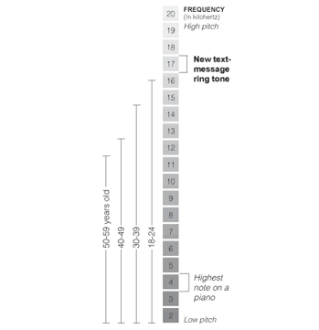

Fig. 1: Hearing ranges by age group‎[1]

What Did We Do?
We implemented a new method that allows exchanging of information between Android-based devices via inaudible sound waves (i.e. ultrasonic data transfer). To do so, we searched for different coding methods and choose frequency-shift keying. Moreover, we researched the dependency of the quality of the transferred data upon different factors such that: characteristics of the devices, the distance between them, and so on.
In addition, we considered the side effects like sound noise. Also, we found that high frequencies can be heard by animals like dogs because some animals can hear higher frequencies than humans.

Why Was It Not Trivial?
The described above challenges of our project were not trivial because we dealt with absolutely new technology: voice-based information transfer in ultrasonic mode on Android devices. It was a new development area for us. We studied Android development and learned how it works and how to use its features.
Moreover, we succeed to transfer data via ultra sound and that was completely new and we didn’t deal with something like this before. Besides, we went deeper into understanding how speakers and microphones work on different phones, mainly because, during our numerious experiments, we discovered that some phones in the market filter frequencies, while others don’t accurately generate high frequency. Thus, they are not supporting the data transfer method we are proposing.

How Did We Overcome The Challenges Of The Implementation?

Android applications can be written in Java. Implementing the project, we extended our knowledge in Java by going through the Internet. When we coded our applications that helped us to manage this development area. We learned Java for Android using:
- https://developer.android.com/training/index.html
- https://www.androidhive.info/
- https://www.tutorialspoint.com/android/index.htm

We studied a lot about ultrasonic waves, and toldd with specialists in the field of ultrasonic waves.

We used and tested different kinds of smartphones and checked their ability to emit and receive ultrasonic waves.

We used the Inaudible Sound as a Covert Channel in Mobile Devices paper as a reference, cf. ‎[16].
We hope to win due to lots of successful methods in the field, described in particular in the following sources:
Patents on Ultrasonic Communication:
- Computer communications using acoustic signals
Holder/Company: Beepcard Inc.
Description: A rather general system for data transmission with ultrasound is presented.
Link: https://www.google.com/patents/US7480692
- Electronic transaction authentication based on sound proximity
Holder/Company: International Business Machines - IBM
Description: Pairing mobile devices: authenticating that the first and second communications devices are in close proximity.
Link: https://patents.google.com/patent/US9082413?oq=US20140129231
- Method and system for close range communication using audio tones
Holder/Company: Raja Raman
Description: close range secured communication using audio tones and a system for carrying out such method. The invention is related to the field of financial transactions through relatively mobile devices using audio tones.
Link: https://www.google.com/patents/US20100106647
- Remote system configuration via modulated audio
Holder/Company: Dechina LLC
Description: they use acoustic ultrasonic signals over the air to connect two devices for remote configuration.
Link: https://www.google.com/patents/US9450812
- providing inaudible codes via computing devices
Holder/Company: Lee Weinblatt
Description: System and method for providing inaudible codes and corresponding information to users via their computing devices.
Link: https://www.google.com/patents/EP2813993A1?cl=en
- Ultrasonic near-field communication
Holder/Company: Facebook
Description: purchase data on an audio signal with one or more ultrasonic frequencies; and transmitting the encoded purchase data to the receiving device, wherein the encoded purchase data is transmitted using a speaker of the source device.
Link: https://www.google.com/patents/US9098865
- Wireless transaction communication
Holder/Company: Chinkle Corporation
Description: Wireless transaction communication apparatus and method use audio (ultrasound) for authentication between smartphone and some receiver (e.g. for payments).
Link: https://www.google.com/patents/US20130268277
- Sonic communication system and method
Holder/Company: Brett Paulson (Zoosh)
Description: Here they specify a general system which uses sonic data transmission. No details on encoding method provided.
Link: https://www.google.com/patents/US20140355386

BACKGROUND AND RELATED WORK

Sound
Sound ‎[6] is produced when an object vibrates the air around it, and this vibration can be represented as a wave that travels through space. For example, if a branch falls off a tree and hits the ground, the air pressure around the branch changes when it hits the earth and, as a result, the vibration of the air produces a sound originating from the collision.
One thing that many people do not realize is that sound waves have physical properties and are therefore influenced by the environment in which they occur. In the vacuum of space, for instance, sounds cannot occur because, in a true vacuum, there is nothing to vibrate and cause a sound wave. The two most important physical qualities of sound are frequency and amplitude.
Frequency is the speed at which a sound wave vibrates, and it determines the pitch of a noise. Higher frequency sounds have a higher pitch, like a flute or a bird chirping, while lower frequency sounds have a lower pitch, like a tuba or a large dog barking. The amplitude of a sound wave can be thought of as the strength of the vibrations as they travel through the air, and it determines the perceived loudness of the sound.
As you can see on Fig. 2, when the peak of the sound wave is smaller, the sound will be perceived as quieter. If the peak is larger, then the sound will seem louder. It might even help to think of sound waves like waves in an ocean. If you stand in still water and drop a pebble near your legs, it will cause a small ripple (a tiny wave) that does not affect you much. But if you stand in the ocean during stormy weather, the large incoming waves may be strong enough to knock you down! Just like the size and strength of water waves, the size, and strength of sound waves can have a big effect on what you hear.
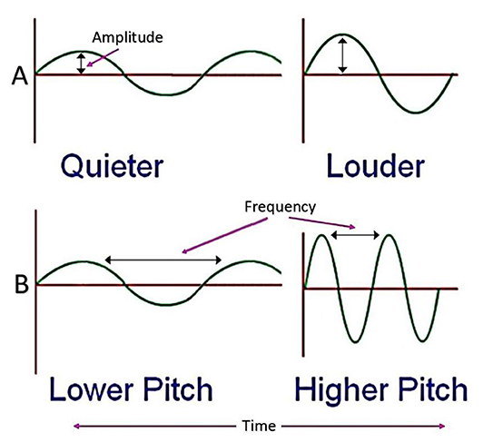

Fig. 2: Amplitude and frequency represented as waves ‎[6]

Amplitude
It is the strength of the vibrations as they travel through the air, the greater the amplitude, the louder the sound is perceived by the observer.

Frequency
It is the speed at which a sound wave vibrates, which determines the perceived pitch of the noise, the greater the frequency, the higher the pitch of the sound.

Pitch
It is the quality of sound that is experienced as a function of the frequency or speed of the vibrations, the perceived degree of highness or lowness of a tone or sound.

Ultrasonic
Ultrasonic ‎[7] is sound waves with frequencies higher than the upper audible limit of human hearing. This limit varies from person to person; humans with ideal hearing can perceive sound frequencies within the range of 20 Hz to 20 kHz. However, sensitivity to high frequencies declines rapidly with age; most humans over 18 years of age cannot hear frequencies above 17 kHz as shown in Fig. 1.
Ultrasonic is not different from “normal” sound (audible sound) in its physical properties, expect that humans cannot hear it.
A significant amount of inaudible frequencies can be produced by mobile device speakers. The small speakers on such devices are better at creating high frequencies. These inaudible frequencies can also be detected by microphones. Therefore, machines can communicate with sound frequencies that most humans cannot hear.
Ultrasonic is used in many different fields, such as to measure distances, imaging, or sonography used in medicine. In our project, we used it as a transferring data method between Android devices.

Different Methods of Voice-based Data Transfer
There are different methods for voice-based data transfer; all these methods are under passband modulation, where a passband is the range of frequencies or wavelengths that can pass through a filter. For example, a radio receiver contains a bandpass filter to select the frequency of the desired radio signal out of all the radio waves picked up by its antenna. The passband of a receiver is the range of frequencies it can receive.
A modulation in electronics and telecommunications is the process of varying one or more properties of a periodic waveform, called the carrier signal, with a modulating signal that typically contains information to be transmitted. Most radio systems in the 20th century used frequency modulation (FM) or amplitude modulation (AM) for radio broadcast.
Passband modulation includes different types of modulations:

Analog Modulation
In analog modulation, cf. ‎[20], the modulation is applied continuously in response to the analog information signal. Common analog modulation techniques include:
  - Amplitude Modulation
Amplitude modulation (AM), cf. ‎[10], is a modulation technique used in electronic communication, most commonly for transmitting information via a radio carrier wave. In amplitude modulation, the amplitude (signal strength) of the carrier wave is varied in proportion to that of the message signal being transmitted. The message signal is, for example, a function of the sound to be reproduced by a loudspeaker, or the light intensity of pixels of a television screen. This technique contrasts with frequency modulation, in which the frequency of the carrier signal is varied, and phase modulation, in which its phase is varied.
AM was the earliest modulation method used for transmitting audio in radio broadcasting. It was developed during the first quarter of the 20th century beginning with Roberto Landell de Moura and Reginald Fessenden's radiotelephone experiments in 1900, cf. ‎[11]. It remains in use today in many forms of communication. For example, it is used in portable two-way radios, very high frequency ‎[27] aircraft radio, citizens band radio, and in computer modems in the form of quadrature amplitude modulation ‎[28]. AM is often used to refer to mediumwave AM radio broadcasting.
  - Frequency Modulation
Frequency Modulation (FM), cf. ‎[12], is the encoding of information in a carrier wave by varying the instantaneous frequency of the wave.
In analog frequency modulation, such as FM radio broadcasting of an audio signal representing voice or music, the instantaneous frequency deviation, the difference between the frequency of the carrier and its center frequency, is proportional to the modulating signal.
Digital data can be encoded and transmitted via FM by shifting the carrier's frequency among a predefined set of frequencies representing digits – for example one frequency can represent a binary 1 and a second can represent binary 0. This modulation technique is known as Frequency-Shift Keying (FSK). FSK is widely used in modems such as fax modems and can also be used to send Morse code, cf. ‎[13]. Radioteletype also uses FSK, cf. ‎[14]
Frequency modulation is widely used for FM radio broadcasting. It is also used in telemetry, radar, seismic prospecting, and monitoring newborns for seizures via ElectroEncephaloGraphy - EEG, cf. ‎[15] two-way radio systems, sound synthesis, magnetic tape-recording systems and some video-transmission systems. In radio transmission, an advantage of frequency modulation is that it has a larger signal-to-noise ratio and therefore rejects radio frequency interference better than an equal power amplitude modulation (AM) signal. For this reason, most music is broadcast over FM radio.
Frequency modulation and phase modulation are the two complementary principal methods of angle modulation; phase modulation is often used as an intermediate step to achieve frequency modulation. These methods contrast with amplitude modulation, in which the amplitude of the carrier wave varies, while the frequency and phase remain constant.
  - Phase Modulation
Phase modulation, cf. (PM) ‎[16], is a modulation pattern for conditioning communication signals for transmission. It encodes a message signal as variations in the instantaneous phase of a carrier wave. Phase modulation is one of the two principal forms of angle modulation, together with frequency modulation.
The phase of a carrier signal is modulated to follow the changing signal level (amplitude) of the message signal. The peak amplitude and the frequency of the carrier signal are maintained constant, but as the amplitude of the message signal changes, the phase of the carrier changes correspondingly.
Phase modulation is widely used for transmitting radio waves and is an integral part of many digital transmission coding schemes that underlie a wide range of technologies like Wi-Fi, global system for mobile communication and satellite television.
PM is used for signal and waveform generation in digital synthesizers, such as the Yamaha DX7, to implement FM synthesis. A related type of sound synthesis called phase distortion is used in the Casio CZ synthesizers.
Out of all these three, cf. ‎[17], amplitude modulation seems more feasible as it can be sent over low frequencies that are inaudible to human ears and thus, won’t create any humming sound or other distractions. Amplitude modulation also means sending data over longer areas as the sound waves with longer wavelength can easily bypass physical obstructions.
Since the digital data is binary, data can be easily mounted to sound waves by creating a short sound to indicate a 0 and a long sound to indicate the 1. At the receiving end, a demodulation (a modem) can be used to decode the message.
The best method to send data over sound would be to use inaudible frequencies and low amplitudes that can span buildings and other obstructions so that they can reach far off places.

Digital Modulation
In digital modulation ‎[21], an analog carrier signal is modulated by a discrete signal. Digital modulation methods can be considered as digital-to-analog conversion and the corresponding demodulation or detection as analog-to-digital conversion. The changes in the carrier signal are chosen from a finite number of M alternative symbols. Common digital modulation techniques include:
- Amplitude-shift keying (ASK)
Amplitude-Shift Keying (ASK) ‎[22] is a form of amplitude modulation that represents digital data as variations in the amplitude of a carrier wave. In an ASK system, the binary symbol 1 is represented by transmitting a fixed-amplitude carrier wave and fixed frequency for a bit duration of T seconds. If the signal value is 1 then the carrier signal will be transmitted; otherwise, a signal value of 0 will be transmitted.
Any digital modulation scheme uses a finite number of distinct signals to represent digital data. ASK uses a finite number of amplitudes, each assigned a unique pattern of binary digits. Usually, each amplitude encodes an equal number of bits. Each pattern of bits forms the symbol that is represented by the amplitude. The demodulator, which is designed specifically for the symbol-set used by the modulator, determines the amplitude of the received signal and maps it back to the symbol it represents, thus recovering the original data. Frequency and phase of the carrier are kept constant.
Like AM, an ASK is also linear and sensitive to atmospheric noise, distortions, propagation conditions on different routes in PSTN, etc. Both ASK modulation and demodulation processes are relatively inexpensive. The ASK technique is also commonly used to transmit digital data over optical fiber. For LED transmitters, binary 1 is represented by a short pulse of light and binary 0 by the absence of light. Laser transmitters normally have a fixed "bias" current that causes the device to emit a low light level. This low level represents binary 0, while a higher amplitude light wave represents binary 1.
The simplest and most common form of ASK operates as a switch, using the presence of a carrier wave to indicate a binary one and its absence to indicate a binary zero. This type of modulation is called on-off keying (OOK), and is used at radio frequencies to transmit Morse code (referred to as continuous wave operation),
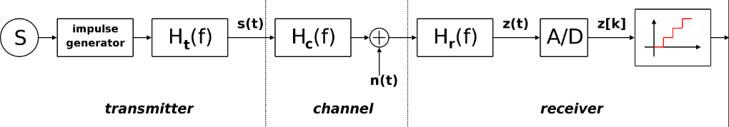
More sophisticated encoding schemes have been developed which represent data in groups using additional amplitude levels. For instance, a four-level encoding scheme can represent two bits with each shift in amplitude; an eight-level scheme can represent three bits; and so on. These forms of amplitude-shift keying require a high signal-to-noise ratio for their recovery, as by their nature much of the signal is transmitted at reduced power.

Fig. 6: ASK diagram ‎[22]
ASK system can be divided into three blocks. The first one represents the transmitter, the second one is a linear model of the effects of the channel, and the third one shows the structure of the receiver. The following notation is used:
- h_{t}(f) is the carrier signal for the transmission
- h_{c}(f) is the impulse response of the channel
- n(t) is the noise introduced by the channel
- h_{r}(f) is the filter at the receiver
- L is the number of levels that are used for transmission
- T_{s} is the time between the generation of two symbols
- Frequency-shift keying (FSK)
Frequency-Shift Keying (FSK) ‎[8] is a frequency modulation scheme in which digital information is transmitted through discrete frequency changes of a carrier signal ‎[23]. The technology is used for communication systems such as telemetry, weather balloon radiosondes, caller ID, garage door openers, and low frequency radio transmission in the very low frequency and extremely low frequency ‎[8] bands. The simplest FSK is binary FSK (BFSK). BFSK uses a pair of discrete frequencies to transmit binary (0s and 1s) information. With this scheme, the "1" is called the mark frequency and the "0" is called the space frequency.
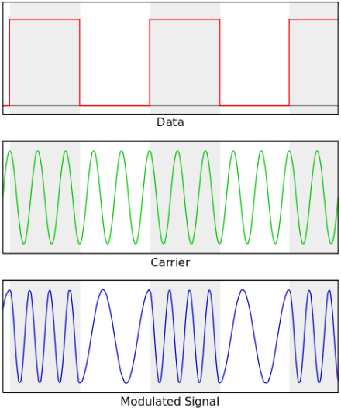

Fig. 3: Example of a digital signal represented as analog waves in frequency shift keying ‎[8]

- Phase-shift keying (PSK)
Phase-Shift Keying (PSK) ‎[23] is a digital modulation process which conveys data by changing (modulating) the phase of a constant frequency reference signal (the carrier wave). The modulation is accomplished by varying the sine and cosine inputs at a precise time. It is widely used for wireless local area networks, radio-frequency identification and Bluetooth communication.
Any digital modulation scheme uses a finite number of distinct signals to represent digital data. PSK uses a finite number of phases, each assigned a unique pattern of binary digits. Usually, each phase encodes an equal number of bits. Each pattern of bits forms the symbol that is represented by the phase. The demodulator, which is designed specifically for the symbol-set used by the modulator, determines the phase of the received signal and maps it back to the symbol it represents, thus recovering the original data. This requires the receiver to be able to compare the phase of the received signal to a reference signal – such a system is termed coherent.
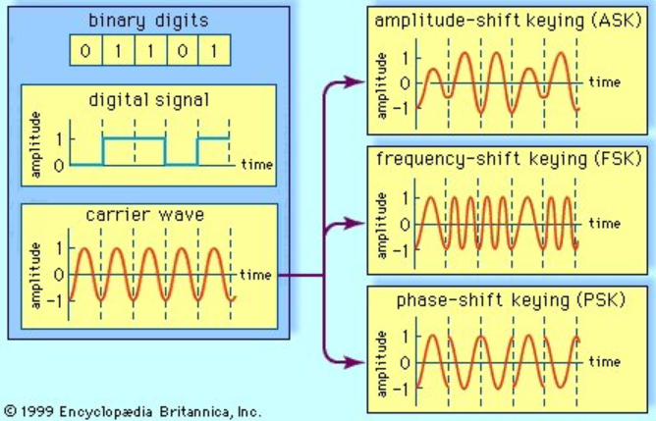
- An example for representing the data of the three methods of the digital modulation:

Fig. 7: Three methods of digital signal modulation ‎[23]

A digital signal, representing the binary digits 0 and 1 by a series of on and off amplitudes, is impressed onto an analog carrier wave of constant amplitude and frequency. In amplitude-shift keying (ASK), the modulated wave represents the series of bits by shifting abruptly between high and low amplitude. In frequency-shift keying (FSK), the bit stream is represented by shifts between two frequencies. In phase-shift keying (PSK), amplitude and frequency remain constant; the bit stream is represented by shifts in the phase of the modulated signal.

Analog and Digital Signals
Analog and digital signals are used to transmit information, usually through electric signals. In both these technologies, the information, such as any audio or video, is transformed into electric signals. The difference between analog and digital technologies is that in analog technology, information is translated into electric pulses of varying amplitude. In digital technology, translation of information is into binary format (zero or one) where each bit is representative of two distinct amplitudes. Here you are the comparison chart ‎[25]:

 | Analog | Digital
Signal | Analog signal is a continuous signal which represents physical measurements. | Digital signals are discrete time signals generated by digital
Waves | Denoted by sine waves | Denoted by square waves
Representation | Uses continuous range of values to represent information | Uses discrete or discontinuous values to represent information
Example | Human voice in air, analog electronic devices. | Computers, Compact Discs, Digital Versatile Discs, and other digital electronic devices.
Technology | Analog technology records waveforms as they are. | Samples analog waveforms into a limited set of numbers and records them.
Data transmissions | Subjected to deterioration by noise during transmission and write/read cycle. | Can be noise-immune without deterioration during transmission and write/read cycle.
Response to Noise | More likely to get affected reducing accuracy | Less affected since noise response are analog in nature
Flexibility | Analog hardware is not flexible. | Digital hardware is flexible in implementation.
Uses | Can be used in analog devices only. Best suited for audio and video transmission. | Best suited for Computing and digital electronics.
Applications | Thermometer | Personal Computers, Personal Digital Assistants
Bandwidth | Analog signal processing can be done in real time and consumes less bandwidth. | There is no guarantee that digital signal processing can be done in real time and consumes more bandwidth to carry out the same information.
Memory | Stored in the form of wave signal | Stored in the form of binary bit
Power | Analog instrument draws large power | Digital instrument draws only negligible power
Cost | Low cost and portable | Cost is high and not easily portable
Impedance | Low | High order of 100 megaohm
Errors | Analog instruments usually have a scale which is cramped at lower end and give considerable observational errors. | Digital instruments are free from observational errors like parallax and approximation errors.

Table 1: Analog and Digital Comparison

Smartphones
Smartphones are a class of mobile phones and of multi-purpose mobile computing devices. They are distinguished from feature phones by their stronger hardware capabilities and extensive mobile operating systems, which facilitate wider software, internet (including web browsing over mobile broadband), and multimedia functionality (including music, video, cameras, and gaming), alongside core phone functions such as voice calls and text messaging. Smartphones support wireless communications protocols (such as Bluetooth, Wi-Fi, or satellite navigation).

Visit Card
Visit cards are cards bearing business information about a company or individual. They are shared during formal introductions as a convenience and a memory aid. A visit card typically includes the giver's name, company or business affiliation (usually with a logo) and contact information such as street addresses, telephone number(s), fax number, e-mail addresses and website. Before the advent of electronic communication visit cards might also include telex details. Now they may include social media addresses such as Facebook, LinkedIn and Twitter. Traditionally, many cards were simple black text on white stock, and the distinctive look and feel of cards printed from an engraved plate was a desirable sign of professionalism. In the late 20th century, technological advances drove changes in style, and today a professional visit card will often include one or more aspects of striking visual design. Below, see Fig. 8 and Fig. 9.
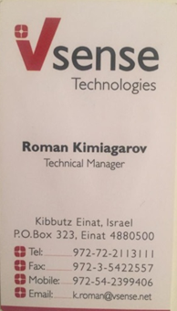
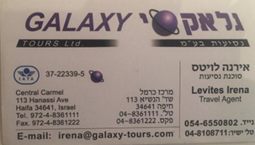

Fig. 8: Tours visit card

Fig. 9: Personal visit card

Android

Android Operating System
Android is software that was founded in Palo Alto of California in 2003. It is a Linux based operating system it is designed primarily for touch screen mobile devices such as smartphones and tablet computers. It is also one of the most widely used mobile operating system these days.
The Android is a powerful operating system, and it supports large number of applications in smartphones. These applications are more comfortable and advanced for the users.
The hardware that supports Android software is based on Advanced RISC Machine (ARM) architecture platform. The Android is an open source operating system means that it’s free and any one can use it.
Android applications are regulated by a permission system that enforces the principle of least privilege. At install time, users are presented with a list of dangerous permissions the application requires to function correctly. These permissions include network access, access to message history, access to contacts, etc. If the user is willing to trust the application with these permissions, they allow the installation to continue. If not, the installation is aborted. In addition, access to the speakers and microphone are not considered dangerous actions and do not require explicit permissions.
Kirin ‎[5] allows users to set custom policies that prevent dangerous combinations of permissions.
TaintDroid ‎[4] tracks sensitive data as it moves within and out of Android devices. TaintDroid can prevent secrets from being exported over network connections, but it does not prevent secrets from being broadcast as sound.
MockDroid ‎[3] provides false data when sensitive data is requested by an application. It can also make an application believe that network access is unavailable. However, an application may be trusted with real data in order to obtain functionality. It can then export the data as sound instead of using the network.

Android Services
A Service is an application component that can perform long-running operations in the background and does not provide a user interface.

Android Application
An Android application is a mobile app. A mobile app is a computer program or software application designed to run on a mobile device such as a phone, tablet, or watch. Apps were originally intended for productivity assistance such as email, calendar, and contact databases, but the public demand for apps caused rapid expansion into other areas such as mobile games, factory automation, GPS and location-based services, order-tracking, and ticket purchases, so that there are now millions of apps available.

Android permissions
The purpose of the permissions is to protect the privacy of an Android user. Android apps must request permission to access sensitive user data (such as contacts and SMS), as well as certain system features (such as camera and internet). Depending on the feature, the system might grant the permission automatically or might prompt the user to approve the request.

Android Software Development Kit – SDK
A software development toolkit (SDK) ‎[36] is a set of software tools and programs provided by hardware and software vendors that developers can use to build applications for specific platforms. These providers make their SDKs available to help developers easily integrate their apps with their services.
In order to use an SDK, a developer needs an iOS SDK to build iOS apps, an Android toolkit for building Android apps, Nordic SDK to build Bluetooth or wireless apps and a VMware SDK to enable integration with the VMware platform.
Although SDKs are largely associated with native mobile apps, developers can use them in connection with websites, set-top boxes and other digital platforms.
SDKs include documentation, application programming interfaces (APIs), code samples, libraries and processes, as well as guides that developers can use and integrate into their apps. Developers can use SDKs to build and maintain applications without having to write everything from scratch.
More specifically, SDKs include:
- Libraries or APIs - pre-defined pieces of code that let developers perform common programming tasks on the platform.
- Integrated development environment (IDE) – a visual editor that helps developers design and layout graphical elements, such as text boxes and buttons. These are common in mobile software development toolkits. For instance, Apple’s IDE, Xcode, contains a suite of software development tools to help developers build software for macOS, iOS, iPadOS, watchOS and tvOS. There are numerous IDE options for Android.
- Tools to help developers do such tasks as debugging, building, running and testing their applications.
SDKs enable developers to enhance apps with more functionality and let them include push notifications, ads and more. SDKs also help developers more efficiently create new tools and make the process easier because everything is prebuilt.
For example, if a developer wanted to share images or text from his or her app directly into Facebook, he or she could look for Facebook’s Android SDK to find the necessary code that would work for an Android device. This speeds deployment because the developer doesn’t have to write the code from scratch.
Why use SDKs
Software development toolkits allow developers to add functionality to their applications and enable them to build the standard components of their apps easier and faster. SDKs are usually all-in-one products and don’t need to be integrated with other components, which can slow down the development process.
Typically, developers use SDKs for simple functions, such logging in, location services and mobile payments. However, there are also SDKs that help developers build more complex app features, such as augmented reality (AR) and virtual reality (VR). SDKs reduce complex integrations by simplifying standard processes, such as creating authorization signatures or interpreting SMS messages in native languages or platforms.
Difference between SDKs and APIs
An API is code that enables two software programs to communicate with each other. An API defines the correct way for a developer to request services from an operating system or other application and expose data within different contexts and across multiple channels.
When a developer uses an SDK to develop applications and create systems, those apps have to communicate with other applications. An SDK includes an API to enable that communication.

OUR APPROACH - ULTRASONIC SOUND BASED DATA TRANSFER
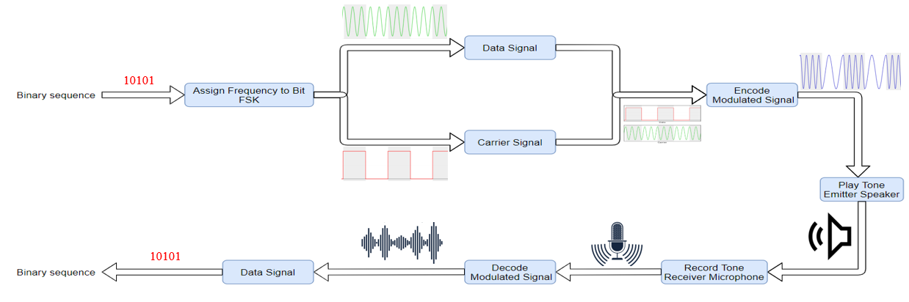
The second team successefully developed an application that passes a binary sequence as an input to our tool., We used an Android API that is aims to generate a tone. We iterate over the sequence and each time we assign 18 kHz to 0's and 19 kHz to 1’s. This method is called FSK. After that, we play the resulted audio track with the highest amplitude to transmit the data to the second phone. Using the same API, we record the audio track on the receiving device. We convert the recorded data from the domain of time to the domain of frequency using fast Fourier transform and choose from all the frequencies the marked frequency, which is between the range of 18 kHz to 19 kHz and with the highest amplitude then convert the frequency to 1 or 0 (binary sequence). Then, we save the digital data in the receiving device's local storage in a memory buffer.
Fig. 28: Transmit To Receive Flow

Materials
The provided investigation of ‎[18] uses FSK functions of ‎[8] by encoding binary 1’s and 0’s as two different frequencies. Each frequency must be predetermined. Their experiments use 18 kHz as the low frequency and 19 kHz as the high frequency. These 1’s and 0’s may be referred to as bits or symbols. If the receiver senses a high tone, it receives a 1. If it receives a low tone, it receives a 0. FSK also uses a set amount of time for each symbol to maintain synchronization and detect repeats of the same symbol. An illustration describing FSK is presented in Fig. 3. The frequencies 18 kHz and 19 kHz were chosen for various reasons. Lower frequencies should be able to travel farther while maintaining their integrity. These frequencies were still too high for the author and experimenters to hear. Hanspatch and Goetz, cf. ‎[9] , used a frequency of 18,600 Hz. The provided investigation ‎[18] found that error rates were significantly higher when they used 19 kHz and 20 kHz. This is likely due to hardware limitations.

Bitrate Experiment
The provided investigation ‎[18] experimented to determine the maximum bitrate our implementation could support at a minimal distance. The minimal distance was obtained by placing two devices back to back without cases. Once the two devices were in position, the receiver was set to record, and the transmitter played the encoded .wav file. After the file finished playing, the receiver was set to decode. Once the receiver finished decoding, it displayed its results to the screen. This experiment was performed in a computer lab. Some ambient noise may have come from air conditioning vents, computer fans, a refrigerator, and researchers typing.

Distance Experiment
A similar experiment was performed to measure the maximum distance at which messages could be passed and accurately decoded. This experiment used a consistent bitrate of 8.61 bits per second, but the distance between devices was varied. In this experiment, the devices were placed in cases that allowed them to be propped up in their tallest orientation. The transmitter’s speaker was turned to face the screens of the receiving devices. One Nexus 7 was used to broadcast to three receiving Nexus 7’s. The frequencies, preliminary tone, synchronization tone, and message were all the same as in the bitrate experiment. The sequence of events (record, play tone, decode, evaluate) was also identical to the bitrate experiments. This experiment was performed in a large hallway in a research building. Ambient noise could have been caused by air conditioning, people walking, and use of doors.

INFORMATION TRANSFER WITH SMARTPHONES

How Smartphones Transfer Voice Data
In short, data-over-sound ‎[29] enables the exchange of data between any devices with a pre-existing loudspeaker or microphone through sound waves. Delivered through machine-to-machine communications software, the technology works like an audio Quick Response code ‎[30], sending data over an acoustic channel to enhance end-user experiences and add value to existing hardware.
In practice, data is encoded into an acoustic signal—a series of audible or inaudible pitches and tones to form a kind of “sonic barcode.” This is then played into a space (usually air but could be Voice over Internet Protocol ‎[31] stream or wired telephone lines) and received and demodulated by a "listening" device. Data is subsequently decoded by the receiving device, or group of devices, and returns the original data.
By using a range of audio frequencies, programmers can fit more information into less audio. To filter out noise, developers carefully select frequencies and tune their software so that their applications can speak to each other to detect and decode data signals in noisy environments, like a busy train platform or concert venue.

Audio File Types
Each audio file type has unique benefits and drawbacks. Determine which one is best for specific tasks or situations to save time and reduce stressful errors. Here are six popular audio file types and some unique differences between them.
- Waveform Audio - WAV
A WAV audio file is a Waveform Audio File that stores waveform data ‎[32]. The waveform data stored presents an image that demonstrates strength of volume and sound in specific parts of the WAV file. It is entirely possible to transform a WAV file using compression, though it’s not standard. Also, the WAV is typically used on Windows systems.
The easiest way to envision this concept is by thinking of ocean waves. The water is loudest, fullest and strongest when the wave is high. The same holds true for the waveform in the WAV. The visuals are high and large when the sound increases in the file. WAV files are usually uncompressed audio files, though it’s not a requirement of the format.
- Audio Interchange - AIFF
AIFF is short for Audio Interchange File Format ‎[33], which is an audio format initially created by Apple Computer for storing and transmitting high-quality sampled audio data. It supports a variety of bit resolutions, sample rates, and channels of audio. This format is quite popular upon Apple platforms and is commonly adopted in professional programs that handle digital audio waveforms.
- M4A
The M4A is a Moving Picture Experts Group (mpeg-4) audio file ‎[32]. It is an audio-compressed file used in the modern setting due to increased quality demand as a result of cloud storage and bigger hard drive space in contemporary computers. Its high quality keeps it relevant, as users who need to hear distinct sounds on audio files will need this over more common file types.
Music download software like Apple iTunes use M4A instead of MP3 because it’s smaller in size and higher in quality. Its limitations come in the form of compatibility, as a lot of software are unable to recognize the M4A, making it ideal for only a select type of user.
- Free Lossless Audio Codec - FLAC
The FLAC audio file is Free Lossless Audio Codec ‎[32]. It is an audio file compressed into a smaller size of the original file. It’s a sophisticated file type that is lesser used among audio formats. This is because, even though it has its advantages, it often needs special downloads to function. When you consider that audio files are shared often, this can make for quite an inconvenience to each new user who receives one.
What makes the FLAC so important is the lossless compression can save size and promote sharing of an audio file while being able to return to the original quality standard. The near-exact amount of storage space required of the original audio file is sixty percent – this saves a lot of hard drive space and time spent uploading or downloading.
- Moving Picture Experts Group Audio Layer 3 - MP3
The MP3 audio file is a Moving Picture Experts Group audio layer 3 file format ‎[32]. The key feature of MP3 files is the compression that saves valuable space while maintaining near-flawless quality of the original source of sound. This compression makes the MP3 very popular for all mobile audio-playing devices, particularly the Apple iPod.
MP3 continues to be relevant in today’s digital landscape because it’s compatible with nearly every device capable of reading audio files. The MP3 is probably best used for extensive audio file sharing due to its manageable size. It also works well for websites that host audio files. Finally, the MP3 remains popular because of its overall sound quality. Though not the highest quality, it has enough other benefits to compensate.
- MP4 Audio File
An MP4 audio file is often mistaken as an improved version of the MP3 file ‎[32]. However, this couldn’t be further from the truth. The two are completely different and the similarities come from their namesake rather than their functionality. Also, note that the MP4 is sometimes referred to as a video file instead of an audio file. This isn’t an error, as in fact it’s both an audio and video file.
An MP4 audio file type is a comprehensive media extension, capable of holding audio, video and other media. The MP4 contains data in the file, rather than code. This is important to note as MP4 files require different codecs to implement the code artificially and allow it to be read.

Why Transfer Over Sound
There are very clear and practical affordances of data over sound ‎[29]. From its seamless integration into existing hardware and frictionless connections, to its ability to work offline in even the most extreme environments, there are myriad potential use cases for data-over-sound.
Data-over-sound has a multitude of complementary capabilities when compared to other connectivity technologies. The technology’s position as a pairing-free, one-to-many medium means it mitigates some of the setup and provisioning pain points often associated with traditional alternatives such as Bluetooth and Wi-Fi, presenting an appealing and versatile solution for frictionless data transmission. In general, compared to other technologies, data-over-sound is also able to be used in very wide application areas, taking advantage of existing hardware and without prior setup or configuration.
Doing so, it enables the interconnection of millions of devices in a seamless, scalable, and cost-effective way to enhance end-user experience and drive value without increasing hardware costs. This ability to enhance existing infrastructure has inevitably captured the interest of companies interested in adding wireless connectivity functionality without adding to their bill of materials.
The future for seamlessly connected devices lies in utilizing a broad range of connectivity solutions, including data-over-sound, where each technology complements the others in the suite. Working in conjunction with other solutions, data-over-sound exists as an essential component of fulfilling the promise of ubiquitous, frictionless connectivity.

The Benefits of Sending Data over Sound
Embedding and extracting meaning from sound provides a quick, secure, and cost-effective solution that works completely offline. Inevitably, there’s no “one-size-fits-all” data-transfer solution that will be optimal in all environments and purposes. Yet, in many situations, data-over-sound is now emerging as an ideal medium for simple implementation and reliable connectivity ‎[29]. Some of the clearest affordances of sound include:
- Works offline
Sound works peer-to-peer, or one-to-many, meaning no additional connections are needed to “the cloud” or other network services. Thus, data-over-sound software works well in a situation where there’s no network access, like rural or RF-restricted areas.
- Utilize existing hardware
The rise of microphones in IoT devices means that the hardware requirements are already met for billions of existing devices of all form factors. Combined with the arrival of zero-power microphones, data-over-sound provides an extremely low power, “always connected,” device-to-device data-transfer solution. Eliminating the need for additional hardware saves users both money and resources that can be invested back into the business.
- Secure, private data transfer
Because acoustic connection doesn’t require an internet connection and supports industry-standard cryptography, you’ll have peace of mind that any data transferred will not be compromised. No audio, not even audio metadata is ever stored or sent from a receiving device for processing.
- Supports range of platforms
Data-over-sound is compatible with machines and devices of different platforms, form factors, and architectures that can process audio. From smartphones and tablets to toys and games, and even legacy and analog equipment, any device with a microphone and speaker can receive and decode data with the technology.
- Seamless integration
Often implementing new software can be resource- and time-intensive. However, data-over-sound can be delivered through software-development kits (SDKs), which provide a fast and easy integration to a host of platform types, making the solution ideal for hobbyist developers and IoT projects.
- Scalable
With data-over-sound, there’s no need to reengineer as your application grows. Whether the aim is to enable seamless P2P exchanges or send data from one-to-many, this method of data transfer is completely scalable. Use cases for data-over-sound are therefore wide ranging. They can include IoT devices sending and receiving commands, secure transactions, and un-spoofable receipts to merchants or buyers, as well as sending/receiving credentials (to provision Wi-Fi, for example).
- Works in extreme environments
Through a range of frequencies, data-over-sound software is robust to background noise and has been proven to work seamlessly in the most extreme environments. From the streets of Delhi to nuclear power stations, acoustic network connectivity remains universally strong in the toughest environments.

Sound Encoding
Audio encoding is just simply translating audio signals to digital. By nature, audio is analog signal. Your voice is analog; any sound you hear is analog. Now for this signal to be able to be transmitted over the internet or any digital medium, it should of course be converted to digital signal. Analog signals are in the form of waveforms, whereas digital signals are in binary form, with bits of 0s and 1s. To be able to be interpreted by the computer, an analog signal should be converted to a digital signal. Various formats of digital audio are MP3, WAV, etc. Now what the audio encoder does is it simply converts your analog audio signal to digital audio signal. On the technical side, audio encoding involves sampling of the analog signal per given time (around a few milliseconds ideally), holding the sampled value, comparing it to a certain threshold voltage. The sampled voltages are then converted to binary values. To make it simple, just imagine you have a handwritten text on a paper. Then you encode it on a computer. In the case of audio, a device, listens to the audio, and converts it to a format readable by your computer. Audio encoding is the process of converting your audio signal into a format readable by your computer, which then can be transmitted through a digital transmission medium.

Sound Decoding
Audio decoding is just simply translating digital to audio signals. Digital signals are in the form of binary, with bits of 0s and 1s. To be able to hear this sound by the computer, a digital signal should be converted to an analog signal. To make it simple, just imagine you have a text written in binary format that’s encoded on your computer. In the case of audio, a device, listens to the audio, and converts it to a format readable by your computer. Audio decoding is the process of converting your digital signal into audio signal that you can hear.
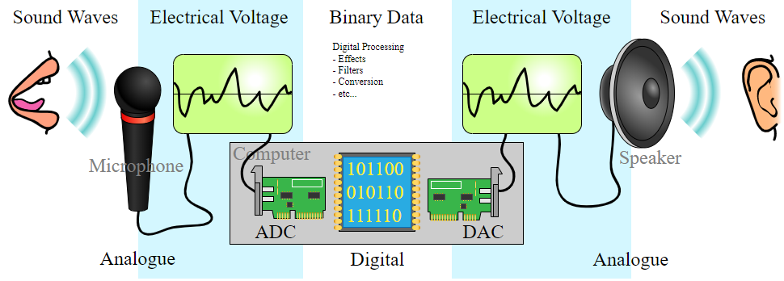

Fig. 20 – Analog to digital signals ‎[40]

- Analog to Digital Converter (ADC) - Converts analog sound into digital signals that can be stored on a computer.
Digital to Analog Converter (DAC) - Converts digital signals stored on a computer into analogue sound that can be played through devices such as speakers.
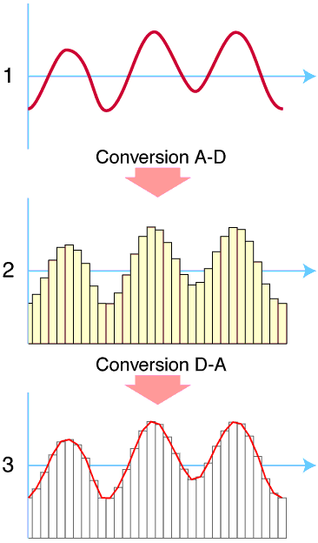

Fig. 21 – ‎[40]
(1) The original analog sound wave is a continuous set of points.
(2) ADC converts sound into digital data.
(3) DAC converts digital data into analog sound, the analog wave produced may differ significantly from the original sound wave.

Sound Compress
Pulse-code modulation (PCM) ‎[34] is a method used to digitally represent sampled analog signals. It is the standard form of digital audio in computers, compact discs, digital telephony and other digital audio applications. In a PCM stream, the amplitude of the analog signal is sampled regularly at uniform intervals, and each sample is quantized to the nearest value within a range of digital steps.
PCM audio can be encoded in many formats for the end user, and these formats fall into two categories: lossless and lossy.

Lossy
Lossy compression enables even greater reductions in file size by removing some of the audio information and simplifying the data. This, of course, results in a reduction in audio quality, but a variety of techniques are used, mainly by exploiting psychoacoustics, to remove the parts of the sound that have the least effect on perceived quality, and to minimize the amount of audible noise added during the process. The popular MP3 format is probably the best-known example, but the AAC format found on the iTunes Music Store is also common. Most formats offer a range of degrees of compression, generally measured in bit rate. The lower the rate, the smaller is the file and the more significant the quality loss.
- Lossy Formats
  - Mpeg Audio Layer 3 – mp3
  - Advanced Audio Coding – AAC

Lossless
A lossless compressed format stores data in less space without losing any information. The original, uncompressed data can be recreated from the compressed version. Uncompressed audio formats encode both sound and silence with the same number of bits per unit of time. Encoding an uncompressed minute of absolute silence produces a file of the same size as encoding an uncompressed minute of music. In a lossless compressed format, however, the music would occupy a smaller file than an uncompressed format and the silence would take up almost no space at all.
Lossless compression formats include the common FLAC, WavPack, Monkey's Audio, ALAC (Apple Lossless). They provide a compression ratio of about 2:1 (i.e. their files take up half the space of PCM). Development in lossless compression formats aims to reduce processing time while maintaining a good compression ratio. Lossless formats are: Waveform Audio File Format – WAV; Audio Interchange File Format – AIFF; Free Lossless Audio Codec – FLAC.

What the difference between lossy and lossless compression
During processing, lossless compression rips audio files so that they reduce in size, but no quality is lost. It's a perfect copy of the original sound. You can also convert one lossless format to another without any loss of quality. But the one thing you can't ever do is converting lossless to lossy, not because it's impossible, it's just a stupid thing to do. For more info, read why converting FLAC to MP3 or WAV vs. MP3 is a terrible thing to do. On the other hand, lossy compression reduces the size of an original file up to ten times, so 100 MB become 10 MB, but some audio data is irreversibly lost therefore it may sound as if a song lacks something, or the other way round, some sound artifacts can appear.

Sound Decompress
Decompression is the process of restoring compressed data to its original form ‎[35]. Data decompression is required in almost all cases of compressed data, including lossy and lossless compression. Similar to compression of data, decompression of data is also based on different algorithms. Decompression is considered important, as compressed data needs to be restored back to standard state for usage. Decompression is widely used in data communications, multimedia, audio, video and file transmissions Decompression is also known as uncompression.
In Fig. 19 below, we can see the overview of the whole transfer process without compressing/decompressing. Compressing the message could be done before the ASCII encoder, and the decompressing should be done after the ASCII decoder.
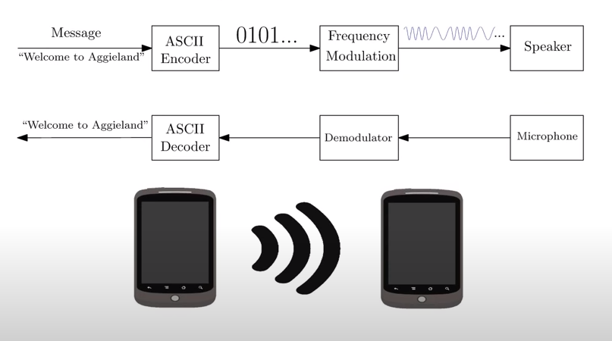

Fig. 19- Overview of the transfer process without compressing/decompressing ‎[41]

GENERAL FLOW OF INAUDIBALE DATA TRANSFER

Implementation details
To understand the design flow the reader is presumed to have an understanding of the following:
Pulse Code Modulation – PCM:
Pulse code modulation ‎[37] is a method that is used to convert an analog signal into a digital signal, so that modified analog signal can be transmitted through the digital communication network. PCM is in binary form, so there will be only two possible states high and low (0 and 1). We can also get back our analog signal by demodulation. The Pulse Code Modulation process is done in three steps Sampling, Quantization, and Coding. There are two specific types of pulse code modulations such as Differential Pulse Code Modulation (DPCM) and Adaptive Differential Pulse Code Modulation (ADPCM). Here (see Fig. 21) is a block diagram of the steps, which are included in PCM.
In sampling we are using PAM sampler that is Pulse Amplitude Modulation Sampler which converts continuous amplitude signal into Discrete-time- continuous signal (PAM pulses). Basic block diagram of PCM is given below for better understanding.

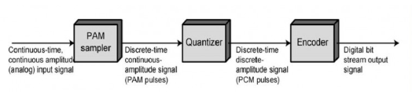

Fig. 21- Block diagram of PCM ‎[37]

What is a Pulse Code Modulation?
To get a pulse code modulated waveform from an analog waveform at the transmitter end (source) of a communications circuit, the amplitude of the analog signal samples at regular time intervals. The sampling rate or number of samples per second is several times the maximum frequency. The message signal converted into binary form will be usually in the number of levels which is always to a power of 2. This process is called quantization.
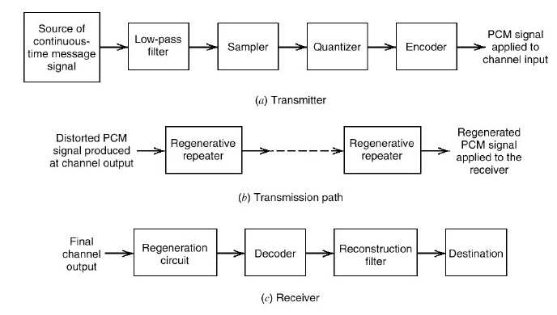

Fig. 22- Basic elements of PCM system ‎[37]
At the receiver end, a pulse code demodulator decodes the binary signal back into pulses with same quantum levels as those in the modulator. By further processes we can restore the original analog waveform.
Pulse Code Modulation Theory
This above block diagram describes the whole process of PCM. The source of continuous time message signal is passed through a low pass filter and then sampling, Quantization, Encoding will be done. We will see in detail step by step.
Sampling
Sampling is a process of measuring the amplitude of a continuous-time signal at discrete instants, converts the continuous signal into a discrete signal. For example, conversion of a sound wave to a sequence of samples. The Sample is a value or set of values at a point in time or it can be spaced. Sampler extract samples of a continuous signal, it is a subsystem ideal sampler produces samples which are equivalent to the instantaneous value of the continuous signal at the specified various points. The Sampling process generates flat- top Pulse Amplitude Modulated (PAM) signal.

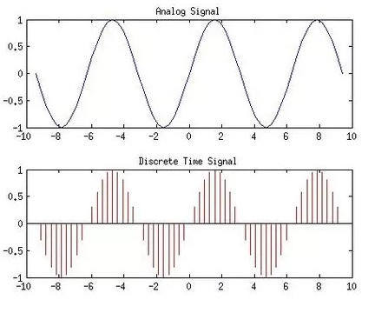

Fig. 23- Analog and sampled signal ‎[37]
Sampling frequency, Fs is the number of average samples per second also known as sampling rate. According to the Nyquist Theorem sampling rate should be at least 2 times the upper cutoff frequency. Sampling frequency, Fs>=2*fmax to avoid Aliasing Effect. If the sampling frequency is very higher than the Nyquist rate it become Oversampling, theoretically a bandwidth limited signal can be reconstructed if sampled at above the Nyquist rate. If the sampling frequency is less than the Nyquist rate it will become undersampling.
- Nyquist Theorem: Nyquist rate is the rate at which sampling of a signal is done so that overlapping of frequency does not take place. When the sampling rate becomes exactly equal to 2fm samples per second, the specific rate is known as Nyquist rate. It is also known as the minimum sampling rate and given by fs =2fm.
- Ideal/Impulse Sampling: An impulse at each sampling instant with amplitude equals to signal at that point of time.
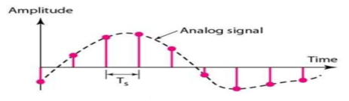

Fig. 24 – Ideal sampling ‎[43]
- Natural Sampling:
A pulse of short width with varying amplitude.
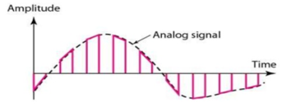

Fig. 25 – Natural sampling ‎[43]

- Flat-top Sampling:
Make use of sample and hold circuit almost like natural but with single amplitude value.
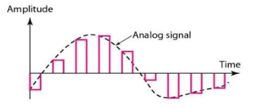

Fig. 26 – Flat-top sampling ‎[43]
Quantization
In quantization, an analog sample with amplitude that converted into a digital sample with amplitude that takes one of a specific defined set of quantization values. Quantization is done by dividing the range of possible values of the analog samples into some different levels and assigning the center value of each level to any sample in quantization interval. Quantization approximates the analog sample values with the nearest quantization values. So, almost all the quantized samples will differ from the original samples by a small amount. That amount is called as quantization error. The result of this quantization error is we will hear hissing noise when play a random signal. Converting analog samples into binary numbers that represent the level number, e.g. suppose using 8-bit it means 2 to the power of 8 levels with values from 00000000 to 11111111 in binary.
We used uniform quantizers. Uniform quantization is applicable when the sample values are in a finite range (Fmin, Fmax). The total data range is divided into 2n levels, let it be L intervals. They will have an equal length Q. Q is known as Quantization interval or quantization step size. In uniform quantization there will be no quantization error.

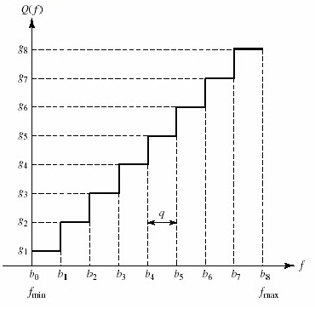

Fig. 27 – Uniformly quantized signal ‎[43]
Coding
The encoder encodes the quantized samples. Each quantized sample is encoded into an 8-bit code word by using A-law in the encoding process.
- Bit 1 is the most significant bit (MSB), it represents the polarity of the sample. “1” represents positive polarity and “0” represents negative polarity.
- Bit 2,3 and 4 will defines the location of sample value. These three bits together form linear curve for low level negative or positive samples.
- Bit 5,6,7 and 8 are the least significant bits (LSB) it represents one of the segments quantized value. Each segment is divided into 16 quantum levels.
PCM is two types Differential Pulse Code Modulation (DPCM) and Adaptive Differential Pulse Code Modulation (ADPCM).
In DPCM only the difference between a sample and the previous value is encoded. The difference will be much smaller than the total sample value, so we need some bits for getting same accuracy as in ordinary PCM. So that the required bit rate will also reduce. For example, in 5-bit code 1 bit is for polarity and the remaining 4 bits for 16 quantum levels.
ADPCM is achieved by adapting the quantizing levels to analog signal characteristics. We can estimate the values with preceding sample values. Error estimation is done as same as in DPCM. In 32Kbps ADPCM method difference between predicted value and sample value is coded with 4 bits, so that we’ll get 15 quantum levels. In this method data rate is half of the conventional PCM.
Emitter Side:

Get A Binary Sequence
Our colleagues from the parallel team transfer to us the binary code that represents the visit card. After we received the binary code from the parallel team, we process it in blocks of 1-bit each and save it into the DataChuncks array.

Generate Tone In A Specific Frequency And Duration – Android API
AudioTrack Class:
The AudioTrack ‎[38] class manages and plays a single audio resource for Java applications. It allows streaming of PCM audio buffers to the audio sink for playback. This is achieved by "pushing" the data to the AudioTrack object using one of the write(byte[], int, int), write(short[], int, int), and write(float[], int, int, int) methods.
An AudioTrack instance can operate under two modes: static or streaming.
In Streaming mode, the application writes a continuous stream of data to the AudioTrack, using one of the write() methods. These are blocking and return when the data has been transferred from the Java layer to the native layer and queued for playback. The streaming mode is most useful when playing blocks of audio data that for instance are:
- too big to fit in memory because of the duration of the sound to play,
- too big to fit in memory because of the characteristics of the audio data (high sampling rate, bits per sample ...)
- received or generated while previously queued audio is playing.
The static mode should be chosen when dealing with short sounds that fit in memory and that need to be played with the smallest latency possible. The static mode will therefore be preferred for UI and game sounds that are played often, and with the smallest overhead possible.
Upon creation, an AudioTrack object initializes its associated audio buffer. The size of this buffer, specified during the construction, determines how long an AudioTrack can play before running out of data. For an AudioTrack using the static mode, this size is the maximum size of the sound that can be played from it. For the streaming mode, data will be written to the audio sink in chunks of sizes less than or equal to the total buffer size.

Pseudo Code
- Initialize:
  - SampleRate = 44100KHz // num of sampling in each second
  - Duration // num of seconds to playing the tone
  - NumOfSamples = SampleRate*Duration
  - SoundData[NumOfSamples]
  - Sampls[NumOfSamples]
  - Ramp = NumOfSamples
- For i = 0 to DataChuncks.size()
  - For j = 0 to NumOfSamples
    - If DataChuncks[i] = 0 Frequency = 18KHz
    - If DataChuncks[i] = 1 Frequency = 19KHz
    - Samples[j] = sin(2*PI*Frequency*i/SampleRate)
  - Ramp = NumOfSamples /20
  - For i = 0 to ramp
  - ramp amplitude up to avoid clicks
  - For i = i to NumOfSamples
  - max amplitude for most of the samples
  - for i = i to NumOfSamples
  - ramp amplitude down
  - instantiate AudioTrack class
  - call write function
  - call play function
Receiver Side:

Start Listening
The receiver clicks the “record” button and then its automatically gives a permission to open the microphone for this action (note: the app already asks for a permission when installed).

Record A Specific Tone – Android API
AudioRecord Class:
The AudioRecord class manages the audio resources for Java applications to record audio from the audio input hardware of the platform. This is achieved by "pulling" (reading) the data from the AudioRecord object. The application is responsible for polling the AudioRecord object in time using one of the following three methods: read(byte[], int, int), read(short[], int, int) or read(java.nio.ByteBuffer, int). The choice of which method to use will be based on the audio data storage format that is the most convenient for the user of AudioRecord.
Upon creation, an AudioRecord object initializes its associated audio buffer that it will fill with the new audio data. The size of this buffer, specified during the construction, determines how long an AudioRecord can record before "over-running" data that has not been read yet. Data should be read from the audio hardware in chunks of sizes inferior to the total recording buffer size.

Pseudo Code
- Initialize:
  - Instantiate AudioRecord Class as Recorder
  - MinBuffSize = AudioRecord.getMinBufferSize
  - DataBuff[MinBuffSize]
  - IsRecording = 1
  - StartOffset = 0
  - DataFile of type ByteArrayOutputStream
- Recorder.startRecording()
- While IsRecording > 0
  - IsRecording= Recorder.read(DataBuffer, StartOffset, MinBuffSize)
  - Write DataBuff to DataFile

Read audio buffer
We assigned a flag to the start, and the end of the transmitted message, when the end flag is received the recording will automatically stop and saves the Data File.

Pseudo Code
- Recorder.stop()
- ChunckSize = DataFile.size() / (SampleRate * Duration)
- Index = 0
- FrequencyArray[SampleRate*Duration]
- Frequency = 0
- DataBit = 0
- StrBinaryChuncks
- foreach sub buffer in DataFile
  - For j = 0 to SampleRate*Duration
    - FrequencyArray[j] = FourierTransform(DataFile[s++])
  - for k = 0 to FrequencyArray.size()
    - If 18.5KHz <= FrequencyArray[k] <= 19KHZ and has higher amplitude than all the previous
      - then DataBit = 1
    - If 18KHz <= FrequencyArray[k] < 18.5KHz and has higher amplitude than all the previous
      - then Databit = 0
  - StrBinaryChuncks += DataBit

Send Binary Chunks
Send StrBinaryChuncks to the parallel team to encode it into a visit card.

EXAMPLE OF INAUDIBALE DATA TRANSFER

Figure 8 – Travel agent visit card
The following example shows the transfer step-by-step according to the above flow:
Emitter Side:
Step 1:
- We assume that the above visit card will be saved in one tuple, it is stored locally on the device memory in a buffer as below in the database:
- name=Levites Irena
- userEmail=irena@galaxy-tours.com
- position_title=Travel Agent
- company=Galaxy Tours
- address=Central Carmel, 113 Hanassi Ave, Haifa 34641, Israel
- Telephone=048361111
- fax=048261222
- mobile=0546550802
All these fields will be combined to one string where a new line is represented as “?”, and after converting to binary this is what we get:
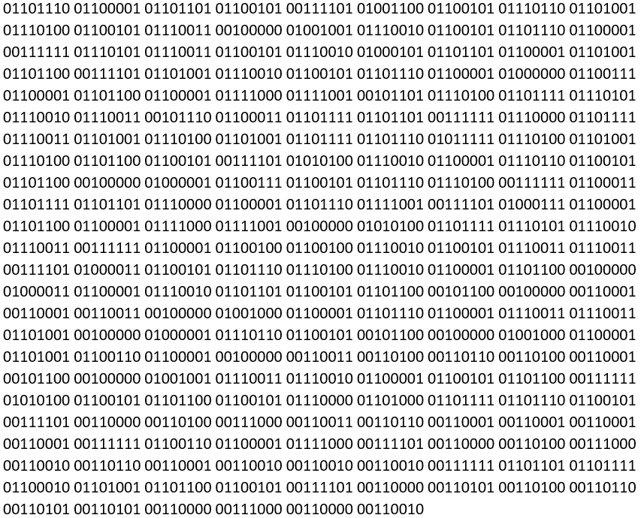

Fig. 27 – binary sequence represented the encoded visit card
Step 2:
- Initialize:
  - SampleRate = 44100KHz // num of sampling in each second
  - Duration // num of seconds to playing the tone
  - NumOfSamples = SampleRate*Duration
  - SoundData[NumOfSamples]
  - Sampls[NumOfSamples]
  - Ramp = NumOfSamples
- For i = 0 to DataChuncks.size()
  - For j = 0 to NumOfSamples
    - If DataChuncks[i] = 0 Frequency = 18KHz
    - If DataChuncks[i] = 1 Frequency = 19KHz
    - Samples[j] = sin(2*PI*Frequency*i/SampleRate)
  - Ramp = NumOfSamples /20
  - For i = 0 to ramp
  - ramp amplitude up to avoid clicks
  - For i = i to NumOfSamples
  - max amplitude for most of the samples
  - for i = i to NumOfSamples
  - ramp amplitude down
  - instantiate AudioTrack class
  - call write function
  - call play function

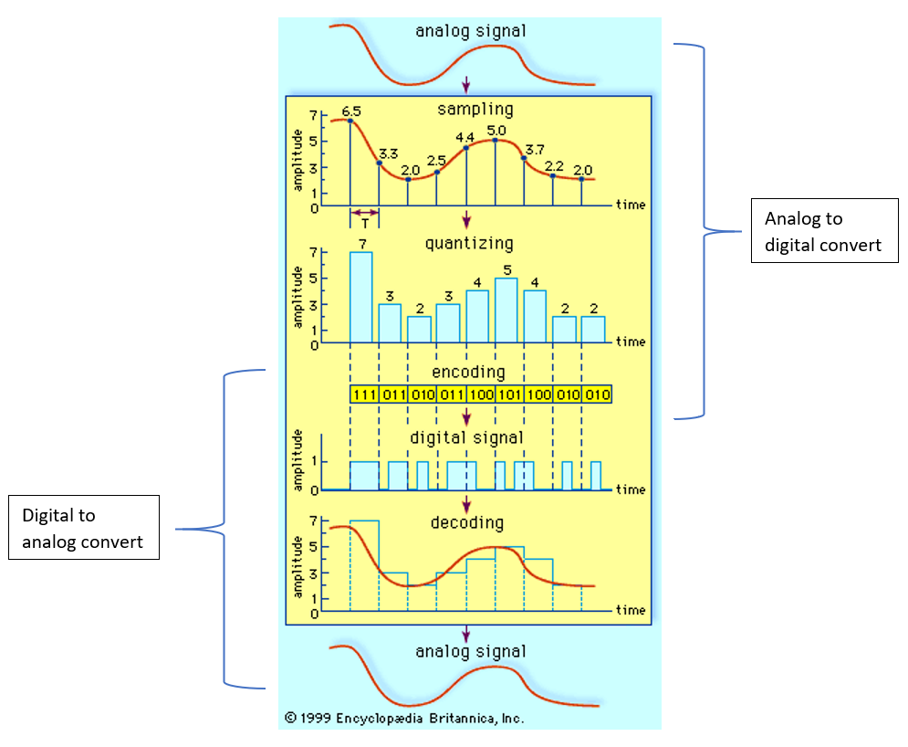

Fig. 20 - ADC and DAC ‎[42]
Receiver Side:
Step 3:
the receiver side clicks the “record” button to enable the startRecording function, so we can save the data locally to the phone.
Step 4:
- Initialize:
  - Instantiate AudioRecord Class as Recorder
  - MinBuffSize = AudioRecord.getMinBufferSize
  - DataBuff[MinBuffSize]
  - IsRecording = 1
  - StartOffset = 0
  - DataFile of type ByteArrayOutputStream
- Recorder.startRecording()
- While IsRecording > 0
  - IsRecording= Recorder.read(DataBuffer, StartOffset, MinBuffSize)
  - Write DataBuff to DataFile
Step 5:
- Recorder.stop()
- ChunckSize = DataFile.size() / (SampleRate * Duration)
- Index = 0
- FrequencyArray[SampleRate*Duration]
- Frequency = 0
- DataBit = 0
- StrBinaryChuncks
- foreach sub buffer in DataFile
  - For j = 0 to SampleRate*Duration
    - FrequencyArray[j] = FourierTransform(DataFile[s++])
  - for k = 0 to FrequencyArray.size()
    - If 18.5KHz <= FrequencyArray[k] <= 19KHZ and has higher amplitude than all the previous
Step 6:
Send to the parallel team the binary sequence that represent the visit card to save it locally in the receiving phone.

RESULTS AND CONCLUSION

Bitrate Experiment
The provided investigation ‎[18] shows that bitrate tests revealed an unexpected limit in our ability to remain stealthy. The Nexus 7 devices produced small amounts of noise outside of the desired frequencies. There were also traces of the clicks which we had reduced by adjusting amplitude during frequency shifts. Neither of these phenomena were audible during transmission at bit rates below 345 bits per second. However, at bitrates above 345 bits per second, the clicks and noise began to form audible tones. A different Android device using a more sophisticated implementation may be able to achieve higher bitrates. In this implementation, we found the effective bitrate limit of stealthy ultrasonic sound to be 345 bits per second.
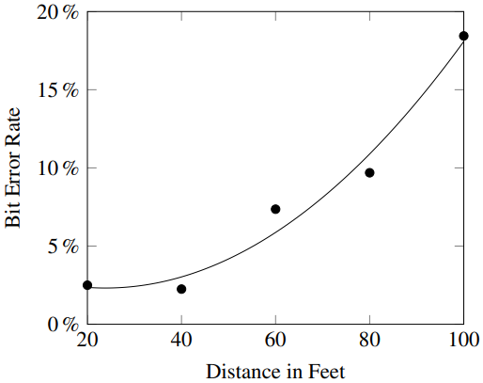

Fig. 4: Average bit error rates at 20-foot intervals. The quadratic regression is also plotted ‎[18]

Distance Experiment
The distance experiment results suggest a decline in transmission reliability as distance increases. Such a decline is expected. We observed a significant increase in error rates at 100 feet. Fig. 4 illustrates their experiment results. These error rates can be overcome with parity schemes, repeated transmissions, and other solutions. We chose to stop experimenting at 100 feet, but transmission at greater distances with the same hardware may also be possible. Our data formed the following formula when we calculated the quadratic regression.
$$errorRate\left(x\right)=0.00271786x^{2}-0.129543x+3.862$$
This formula has an adjusted $R^{2}$ score of 0.950 for the fit of the data to the regression. During experimentation, we encountered a limitation of our character-based decoding. Some attempts to decode transmissions produced strings too short to evaluate. We suspect that an end of string character was encountered which caused the rest of the transmission to be omitted. Fig. 5 plots the rates of occurrence of this phenomenon. The chart contains an outlier at 60 feet where this error did not occur during experiments. Further testing would likely produce a quadratic regression like our bit error rate. This is an implementation specific phenomenon, but we still value these results.

Smart Visit Card Transfer Experiment Results
With the help of the second team, we successfully created, encoded, decoded and transferred a Visit Card from one smartphone to other smartphone using the sound-based transfer, which we developed from scratch.
During the testing we came into the following results:

Distance testing:
For the testing, we sent different visit cards with an average of 130 characters per card.
Transmitter | Receiver | Distance | Result | Notes
S9 | Note 8 | 50 cm | Pass
Note 8 | S9 | 50 cm | Pass
Note 8 | S9 | 100 cm | Pass
S9 | Note 8 | 100 cm | 80% Pass
Note 8 | S9 | Less than 50 cm | Failed | In pocket
S9 | Note 8 | Less than 50 cm | Failed | In pocket
S9 | Note 8 | More than 110 cm | Failed
Note 8 | S9 | More than 110 cm | Failed
Table 9: Distance testing results

Performance measurement:
One of the most challenging parts was the time of transferring of a whole visit card.
The average size of a visit card is about 130 characters and 1040 bits in binary representation and with the help of the second team, they compress the visit card by ~15%, and finally, we have to transfer 884 bits on average.
At first, we sent 1 bit in 0.3 seconds and that took us ~4.5 minutes to transfer a visit card.
So we took it to the next step and send 4 bits at a time and that speed up the performance by 4, after that we can send a visit card in ~ 1.1 minutes.
After manipulation the tune duration in the sender and the buffer size in the receiver we have successfully sent 4 bits in 0.04 seconds and finally we can send an average visit card in ~8 seconds!!!

Challenges During Implementation Part

Challenge Number 1:
Description: Dealing with different speakers and microphones HardWare (HW).
Difficulties Encountered: After our numerious experiments with different Android based devices, it turned out that not all the phones have the same qualities in its built-in HW. In fact, we spent a lot of time trying to understand HW capability and how does the phone react on both sides emitter and receiver.
Dealing With The Difficulties: first of all, we implemented two basic applications, one for producing ultrasound in a specific frequency. The second one was receiving that frequency and printing its value. Then, we have collected different devices and tried them under our basic and existing applications, and we figured out the following for each of them:
- Samsung A11, A51 – are producing ultrasound with an audible frequency (the most audible frequncies was between 5-8 Khz), receiving was as expected, we used it a lot as a receiver in our tests.
- Samsung J3, S8, S9, Note8 – both are producing and receiving as expected.
- Samsung Tab A6 – doesn’t work as expected on both sides.
We also tried to reach Samsung engineers to better understand the exact HW that is used for each device, until now (6.12.2020). Unfortunatly, we have not receive any response Yet.

Challenge Number 2:
Description: Security mechanism.
Difficulties Encountered: We didn’t know which specific permissions are required for speaker and microphone to enable send and record sound and we also didn’t know that we have to implement a method that asks for both of these permissions.
Dealing with the difficulties: Using the Android developer's website reference we figured and learned the entire required flow and the needed methods to be implemented as shown on Fig 34.
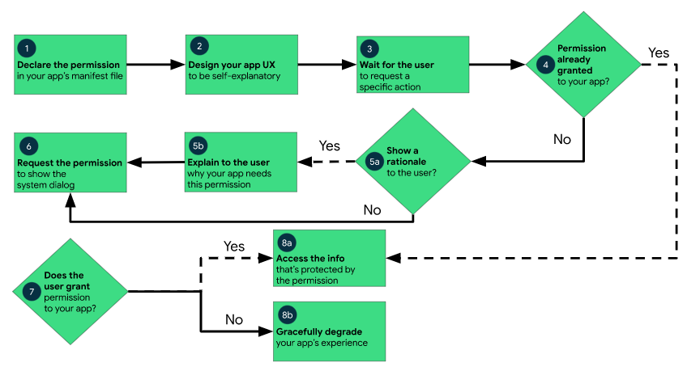
Fig. 34: Workflow for using permissions on Android

Challenge Number 3:
Description: Transffiring digital data into sound and vice-versa.
Difficulties Encountered: How to represent a single binary digit by sound. Initially, we thought to fully implement the flow in the hardware side.
Dealing With The Difficulties: With the help of our supervisor Dr. Elena Ravve we told to an expert, who used to work at Motorola Semiconductor Israel Ltd. and he directs us to find an Android API that has the required accesses to the hardware. So, we studied those API’s deeply to use them in a correct way aligned to our implementations, Audio Record class was the receiver API and Audio Track class was the transmitter.

Challenge Number 4:
Description: Multithreading.
Difficulties Encountered: On the receiver side the App didn’t work well because it didn’t simultaneously record the data. In fact, the problem was that both of the recorder and decoding functions worked on the same thread. Unfortunatly, we didn’t know that these two functions need to work side by side in the background to enhance the performance.
Dealing With The Difficulties: We sent a thread with a high priority to record and store data into a queue while the main thread took care of decoding the sound,. Crearly, the record should be with a high priority to not lose data. In order to create a new thread we had to override and implement the Runnable function by ourselves. See below links for more information:
- https://developer.android.com/reference/java/lang/Runnable
- https://developer.android.com/reference/android/os/Process

Challenge Number 5:
Description: How to represent a wave by frequencies.
Difficulties Encountered: Understanding the results that we got from the Audio Record API.
Dealing With The Difficulties: After profound research, we found that the buffer represents a domain of time. By using Fast Fourier Transform, we can convert back to a domain of frequencies and that’s how we get our data.
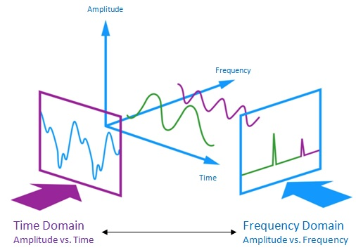

Fig. 35: Time and Frequency Domains

Challenge Number 6:
Description: Noise affects.
Difficulties Encountered: Different noises like human voice, electronic devices, computer, etc…might cause interruptions of detecting the correct frequencies.
Dealing With The Difficulties: In order to choose the wanted sound from the surrounding sounds we took into considerations two factors: the first one is the range of the frequency 18 to 19 Khz and the second one is the highest of the magnitude. So, each frequency out of this range will be dropped,. In addition, we sent the sound in the highest magnitude to filter frequencies on the range with lower magnitude.

Challenge Number 7:
Description: It is a new development area for us, which we haven't experienced yet.
Difficulties Encountered: some required functions were found missing and we didn’t know that. XML files were generated in a wrong way like “Runnable”, “onRequestPermissionsResult” functions.
Dealing With The Difficulties: we learned from experts on the Internet like “EngineersDream” on youtube and the Android developer's website.

Challenge Number 8:
Description: Sound
Difficulties Encountered: We didn’t fully understand how to convert analog signals to digital signals and vice versa.
Dealing With The Difficulties: We asked for help from students and lecturers from the electrical department Ort Braude, we still need to get help from Samsung engineers to decide which phones to use. We also had a session with an analog engineer Majd Tourk from SolarEdge company about sound waves. He helped us to understand deeply how wave transformation works and which method is fastest for decoding. Moreover, he explained how to get the relevant information from a wave.

Challenge Number 9:
Description: Open and close connections.
Difficulties Encountered: While recording signals we didn’t know when to start and stop the record.
Dealing With The Difficulties: we implemented a handshake with two different frequencies 17.5Khz and 19.5Khz to be an opening handshake and a closing handshake to know when to start recording and when to stop it.

Challenge Number 10:
Description: Performance
Difficulties Encountered: Sending one bit per tune is too slow.
Dealing With The Difficulties: While developing the receiver side, we printed out the frequencies that had been received and saw that for each one there can be an approximation error by 10 Hz. So, we decided to send more than one bit per one tone because we have a range from 1000 Hz from 18000 to 19000. Then ,we tried to send more than one bit per tune and it worked well on 4 bit per tune. It means that finally, our performance boosted by x4.

Challenge Number 11:
Description: When the speaker starts working there is a click sound.
Difficulties Encountered: Hearing the clicks once opening and closing connection.
Dealing With The Difficulties: We researched and found in StackOverflow a way to avoid clicks by ramping-up and down the amplitude in the beginning and the end of one tone.
Link for more information:
- https://stackoverflow.com/questions/2413426/playing-an-arbitrary-tone-with-android

Challenge Number 12:
Description: Encoding a visit card by the minimum binary sequence as possible.
Difficulties Encountered: To transmit a whole visit card in the fastest way the other team must provide us minimized binary sequence.
Dealing With The Difficulties: We had a brainstorming meeting with the other team to discuss methods of how we can get the minimum size of data to be transmitted because that is the purpose of the project. Eventually, they compressed the Visit Card by 17-percent.

Challenge Number 13:
Description: All parameters in receiver and transmitter must be matching.
Difficulties Encountered: If there is an unmatching parameter on one of the sides then the receiver decodes the data wrongly. The hardest parameter was to compare is the tune duration versus buffer size.
Dealing With The Difficulties: We calculated the average time for a buffer to get it full on the receiver side and match the number to the duration for a tune to be sent on the transmitter side.

Challenge Number 14:
Description: Reducing transmit time.
Difficulties Encountered: we successfully tranmitted a Visit Card of a 130 charcters in average in a 4.5 minutes.
Dealing With The Difficulties: we decided to reduce the duration time which raised the error rate, so we had to try and test multiple times to decide which one is the perfect time we need to use, and we successfully reduced transmiting time to a 15 seconds and less.

PRELIMINARY SOFTWARE ENGINEERING

Requirements (Use Case)

Requirements
In our application, the user can manage visit cards on her/his mobile device, create new visit cards, edit existing ones, and send/receive ones via voice-based transfer.
- Login activity:
Description: Login into the application, includes a Facebook/Google login button.
Input: email and password.
Output: If the person exists, logging into the application. Otherwise, if the user does not exist in DB, an error message will pop up. If the email does not match the password, an error message will pop up, and if at least one of the fields is empty an appropriate message will pop up.
- Register activity:
Description: The user can register with username and password.
Input: first name, last name, email, job, company, password.
Output: If the username does not exist on DB, the user will be added to the DB. Otherwise, if the email already exists, a pop-up message with request to choose another email will appear, Otherwise, the user have to confirm her/his password if it is not matching an appropriate message will pop up.
- Main activity:
Description: The main screen of the application, where the user can see her/his visit cards or the visit cards that receive from another users. So, the user can manage them.
Input: The user chooses a desired option.
Output: The user redirected to the suitable screen to her/his choice.
- Edit Profile activity:
Description: The user can view or modify her/his personal info.
Input: The user can choose a desired attribute(s) to change.
Output: Upon clicking the "save" button, if the entered attribute(s) are legal, the new data will be saved to the DB, and a success message will pop up. Otherwise, if one of the attribute(s) is illegal, a pop-up message with a request to correct the suitable field(s) will appear.
- Create New Visit Card activity:
Description: The user creates new visit card. Upon creating the new visit card, the user can fill her/his visit card’s attributes.
Input: Name, mobile, job, company, email, address, telephone, fax, logo.
Output: If the user didn’t fill her/his name, email, job, or one of them are empty a pop-up message with a request to correct the suitable field(s) will appear. Upon pressing the save button the user will be directed to the Main screen.
- Edit Visit Card activity:
Description: The user can view or modify her/his visit card’s attributes.
Input: The user can choose a desired attribute(s) to change.
Output: Upon clicking the “Confirm” button, if the entered attribute(s) are legal, the new data will be saved to the DB, and a success message will pop up. Otherwise, if one of the attribute(s) is illegal, a pop-up message with a request to correct the suitable field(s) will appear.
- Delete Visit Card activity:
Description: The user can delete her/his visit card.
Input: The user can choose the visit card that he/she wants to delete.
Output: Upon clicking the “Delete” button, all the info about this visit card will delete from the DB, and a success message will pop up.
- Send Visit Card activity:
Description: The user can send her/his visit card to another users.
Input: The user can choose the visit card that he/she wants to send.
Output: Upon clicking the “Send” button, a success message will pop up.
- Receive Visit Card activity:
Description: The user can receive visit card from another users.
Input: The user can choose the visit card that he/she wants to save from the amount of the visit card that he/she received in the inbox.
Output: Upon clicking the “Accept” button, all the info about this visit card will save in the DB, and a success message will pop up.
- Change Password activity:
Description: The user can change her/his password.
Input: Old password, new password, confirm new password.
Output: If the old password does not match the one in the DB, an error message will pop up. Otherwise, if the new password does not match the confirmed new password, then an error message will pop up. Otherwise, the new password will be updated in the DB, and a success message will appear.
- Search activity:
Description: The user can search for specific visit card.
Input: Search string and after the search results are shown he/she can choose one of the visit cards in the list.
Output: If there are results from the DB, they will be shown below the search bar. Otherwise, if there are no results, a message will notify the user that no results found for her/his search.

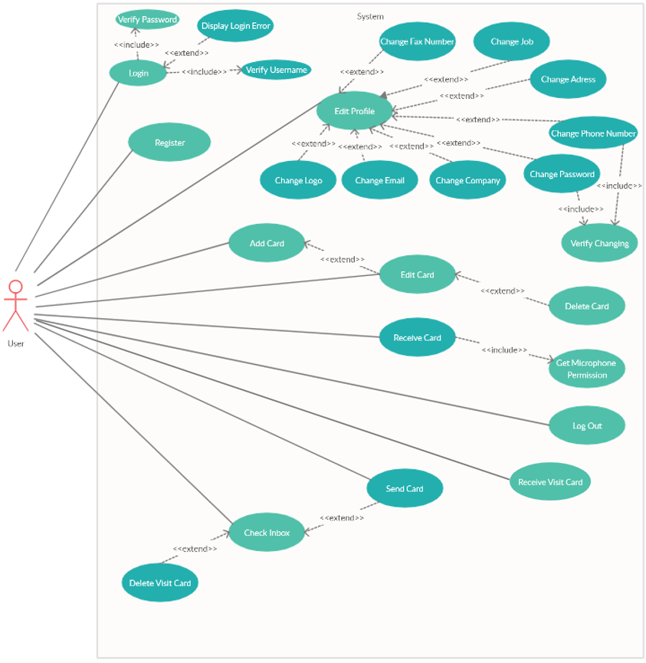
Use Case
Fig. 29: Use Case Diagram

Design (GUI, UML diagrams)

GUI
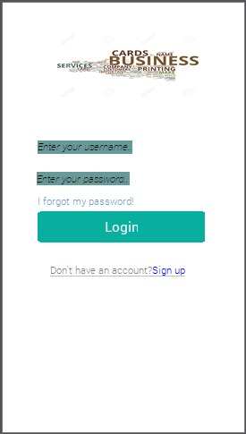
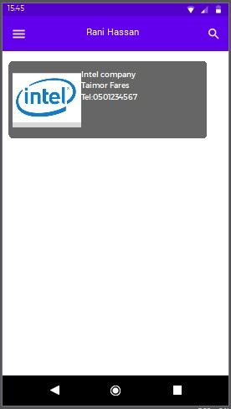
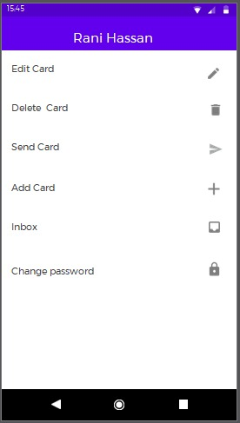
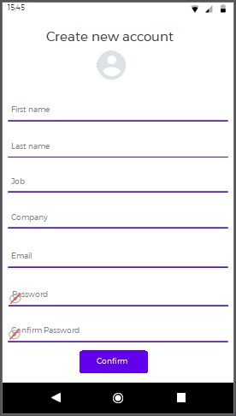
Figure 10 – Login screen
Figure 12 – Home page
Figure 13 – User settings
Figure 11– Register screen

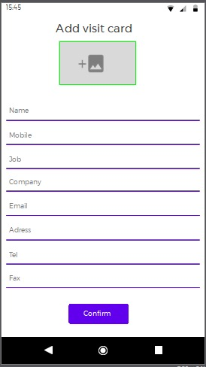
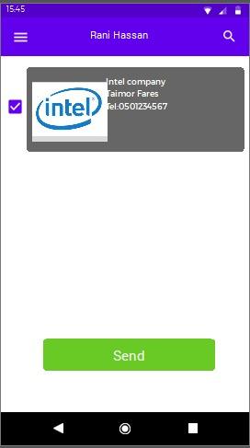
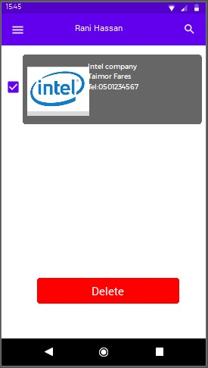
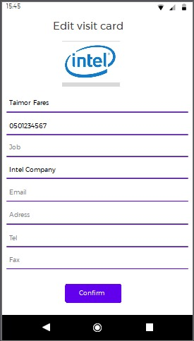
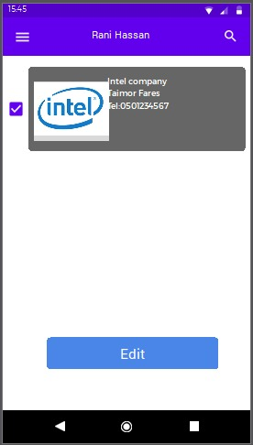
Figure 18 – Add a new visit card
Figure 16 – Send a visit card
Figure 17 – Remove visit card
Figure 14 – Edit visit card - button
Figure 15 – Edit visit card

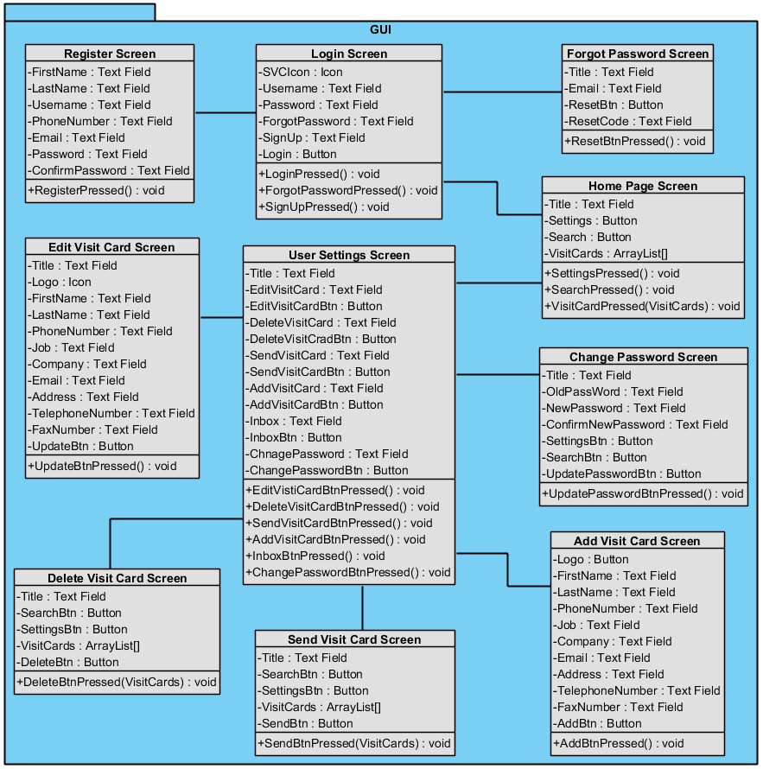
Class Diagrams

Fig. 30: GUI Class Diagram

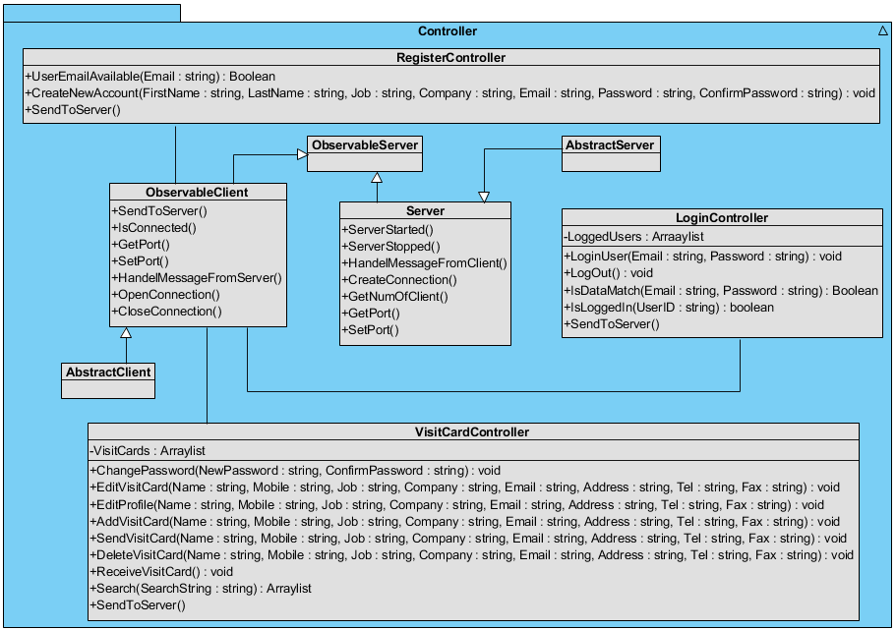
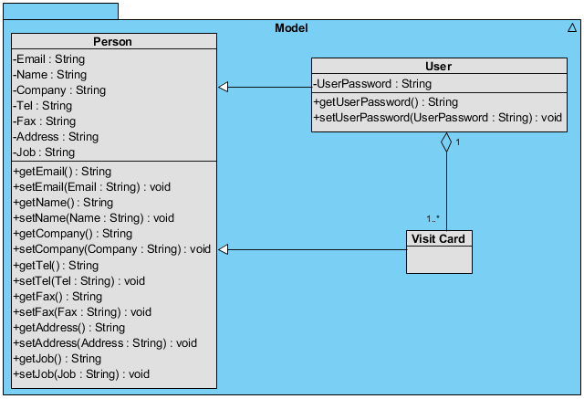
Fig. 32: Controller Class Diagram
Fig. 31: Model Class Diagram

Ultrasound Transfer UML
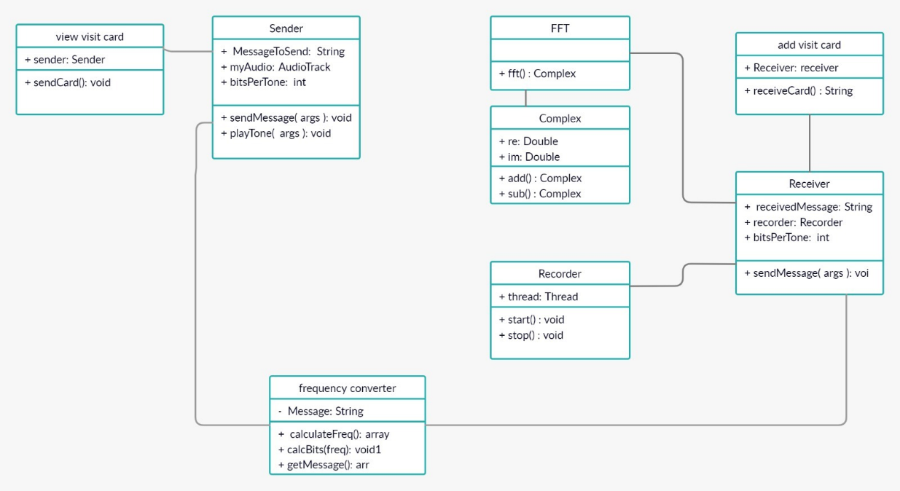

Fig. 35: Ultrasound Class

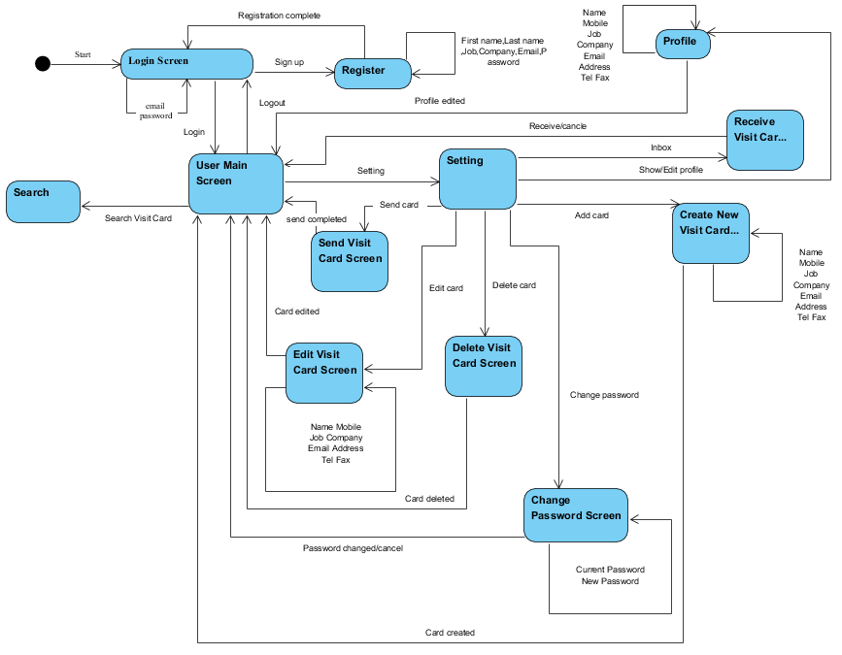
Activity Diagram
Fig. 33: Activity Diagram

Testing plan

Login
Test ID | Initiating actor | Description | Expected results | Observed results
Successful Login | User | The user entered correct Email and password and pressed “login” button. | The "SVC" application is displayed. | Pass – The Home page is displayed.
User Email Does Not Exist | User | The user entered wrong Email which is not in DB and pressed “login” button. | An error message will be shown: “Username not exists”. | Pass – “Incorrect credentials” alert is displayed
Incorrect Password | User | The user entered a username with wrong password and pressed “login” button. | An error message will be shown: “Invalid login!”. | Pass – “Incorrect credentials” alert is displayed
Empty Email Field | User | The user didn’t entered username and pressed “login” button. | An error message will be shown: “Insert your Email”. | Pass – “One or more of the fields is missing” alert is displayed.
Empty Password Field | User | The user didn’t entered password and pressed “login” button. | An error message will be shown: “Insert your Password”. | Pass – “One or more of the fields is missing” alert is displayed.
Table 2: Testing plan- Login

Create a New Visit Card
Test ID | Initiating actor | Description | Expected results | Observed results
Successful Creating | User | The user fills all mandatory fields correctly. | The new visit card will be added to DB and a message will be shown: “Creating completed”. | Semi-Pass – No alert is shown but the user is taken back to the home page.
Empty Name Field | User | The user didn’t enter name and pressed “create” button. | An error message will be shown: “Mandatory field, please insert your name”. | Pass – “Mandatory fields missing” alert is displayed.
Empty Job Field | User | The user didn’t enter job and pressed “create” button. | An error message will be shown: “Mandatory field, please insert your job”. | Pass – “Mandatory fields missing” alert is displayed.
Empty Email Field | User | The user didn’t enter email and pressed “create” button. | An error message will be shown: “Mandatory field, please insert your email”. | Pass – “Mandatory fields missing” alert is displayed.
Incorrect Name | User | The user chose an incorrect name and pressed “create” button. | An error message will be shown: “Username is not match”. | Pass – “Invalid name, it must contain only English letters” alert is displayed.
Incorrect Email | User | The user entered an incorrect email and pressed “createbutton. | An error message will be shown: “Email is not match”. | Pass – “Invalid email” alert is displayed.
Table 3: Testing plan- Create new visit card

Register
Test ID | Initiating actor | Description | Expected results | Observed results
Successful Registration | Unregistered user | The user fills all mandatory fields correctly. | The user will be added to DB and a message will be shown: “Registration completed”. | Pass – “Successfully registered” alert is displayed.
Empty Name Field | Unregistered user | The user didn’t enter name and pressed “register” button. | An error message will be shown: “Mandatory field, please insert your name”. | Pass – “One or more of the fields is missing” alert is displayed.
Empty Password Field | Unregistered user | The user didn’t enter password and pressed “register” button. | An error message will be shown: “Mandatory field, please insert password”. | Pass – “One or more of the fields is missing” alert is displayed.
Empty Email Field | Unregistered user | The user didn’t enter email and pressed “register” button. | An error message will be shown: “Mandatory field, please insert your email”. | Pass – “One or more of the fields is missing” alert is displayed.
Invalid Picture | Unregistered user | The user chose a wrong file format as a profile picture. | An error message will be shown: “File format not supported”. | Fail – We did not implement adding profile pictures due to the short time frame.
Username Exists | Unregistered user | The user chose a username that is already in use. | An error message will be shown: “Username is occupied, please choose another”. | Pass – “Email exists” alert is displayed.
Table 4: Testing plan- Register
בב

Edit Visit Card
Test ID | Initiating actor | Description | Expected results | Observed results
Successful Editing | User | The user fills all mandatory fields correctly and modifies other attributes as he/she wants. | The visit card will be updated in DB and a message will be shown: “Editing completed”. | Semi-Pass – no alert is shown, but the user is taken back to the home page.
Empty Name Field | User | The user didn’t enter name and pressed “edit” button. | An error message will be shown: “Mandatory field, please insert your name”. | Pass – “Mandatory fields missing” alert is displayed.
Empty Job Field | User | The user didn’t enter job and pressed “edit” button. | An error message will be shown: “Mandatory field, please insert your job”. | Pass – “Mandatory fields missing” alert is displayed.
Empty Email Field | User | The user didn’t enter email and pressed “edit” button. | An error message will be shown: “Mandatory field, please insert your email”. | Pass – “Mandatory fields missing” alert is displayed.
Incorrect Name | User | The user chose an incorrect name and pressed “edit” button. | An error message will be shown: “Username is not match”. | Pass – “Invalid name, it must contain only English letters” alert is displayed.
Incorrect Email | User | The user entered an incorrect email and pressed “edit” button. | An error message will be shown: “Email is not match”. | Pass – “Invalid email” alert is displayed.
Table 5: Testing plan- Edit visit card

Edit User Profile
Test ID | Initiating actor | Description | Expected results | Observed results
Successful Editing | User | The user fills all mandatory fields correctly and modifies other attributes as he/she wants. | The user will be updated in DB and a message will be shown: “Editing completed”. | Semi-Pass – no alert is shown, but the user is taken back to the home page.
Empty Name Field | User | The user didn’t enter name and pressed “edit” button. | An error message will be shown: “Mandatory field, please insert your name”. | Fail – We did not add the option of editing the name.
Empty Job Field | User | The user didn’t enter job and pressed “edit” button. | An error message will be shown: “Mandatory field, please insert your job”. | Fail – We did not add a Job field to the User table in the DB.
Empty Email Field | User | The user didn’t enter email and pressed “edit” button. | An error message will be shown: “Mandatory field, please insert your email”. | Fail – We did not add the option of editing the email.
Incorrect Name | User | The user chose an incorrect name and pressed “edit” button. | An error message will be shown: “Username is not match”. | Fail – We did not add the option of editing the name.
Incorrect Email | User | The user entered an incorrect email and pressed “edit” button. | An error message will be shown: “Email is not match”.  Table 6: Testing plan- Edit user profile | Fail – We did not add the option of editing the email.

Change Password
Test ID | Initiating actor | Description | Expected results | Observed results
Invalid New Password | User | The user entered new password which length is less than six. | An error message will be shown: “Password length must be at least six”. | Pass - “Password must be at least 8 characters long and contain at least 1 digit, 1 small case letter, and 1 upper case letter” alert is displayed
Confirm Password Not Match | User | The user entered confirm password which doesn’t match to the new password and pressed “save” button. | An error message will be shown: “Confirm password doesn’t match to new password”. | Pass – “passwords do not match” alert is displayed.
Wrong Old Password | User | The user entered wrong old password and pressed “save” button. | An error message will be shown: “Old password is incorrect”. | Fail – We did not add this field.
Empty New Password Field | User | The user didn’t enter new password and pressed “save” button. | An error message will be shown: “New password is mandatory”. | Pass – “One or more of the fields is missing” alert is displayed.
Empty Confirm Password Field | User | The user didn’t enter confirm password and pressed “save” button. | An error message will be shown: “Confirm password is mandatory”. | Pass – “One or more of the fields is missing” alert is displayed.
Empty Old Password Field | User | The user didn’t enter old password and pressed “save” button. | An error message will be shown: “Old password is mandatory”. | Fail – We did not add this field.
Table 7: Testing plan- Change password

Send/Receive Visit Card
Test ID | Initiating actor | Description | Expected results | Observed results
Send String | User | The user entered “Hello World” string | “Hello World” atring accepted | Received
Send Long String | User | The user entered long string | Message received successfully | Received
Send Empty String | User | The user sends empty message | No message received | Nothing received
Send Short String | User | The user entered short string | Message received successfully | Received
Send String In High Frequency | User | The user entered string in high frequency (i.e. “FFFFFFF…….F”) | Message received successfully | Successfully received
Send String In Low Frequency | User | The user entered string in low frequency (i.e. “0000000……..0”) | Message received successfully | Successfully received
Table 8: Testing plan- Send/Receive Visit Card

REFERENCES
- A ring tone meant to fall on deaf ears - new york times. Web site: https://www.nytimes.com/2006/06/12/technology/12ring.html?r
- Android operating system what is that? https://www.elprocus.com/what-is-android-introduction-features-applications/
- BERESFORD, A. R., RICE, A., SKEHIN, N., AND SOHAN, R. Mockdroid: trading privacy for application functionality on smartphones. In Proceedings of the 12th workshop on mobile computing systems and applications (2011), ACM, pp. 49–54.
- ENCK, W., GILBERT, P., CHUN, B.-G., COX, L. P., JUNG, J., MCDANIEL, P., AND SHETH, A. Taintdroid: An informationflow tracking system for realtime privacy monitoring on smartphones. In OSDI (2010), vol. 10, pp. 1–6.
- ENCK, W., ONGTANG, M., AND MCDANIEL, P. Mitigating android software misuse before it happens. Citeseer (2008).
- Henning D, Sabic E and Hout M (2018) Hear and There: Sounds from Everywhere! Front. Young Minds. 6:63. doi: 10.3389/frym.2018.00063 - https://kids.frontiersin.org/article/10.3389/frym.2018.00063#KC2
- what is Ultrasonic? https://www.wikilectures.eu/w/Ultrasound, https://en.wikipedia.org/wiki/Ultrasound
- Frequency-shift keying - wikipedia, the free encyclopedia. Web site: http://en.wikipedia.org/wiki/Frequencyshiftkeying
- HANSPACH, M., AND GOETZ, M. On covert acoustical mesh networks in air. Journal of Communications 8, 11 (2013).
- Amplitude Modulation - https://en.wikipedia.org/wiki/Amplitude_modulation
- "Father Landell de Moura: Radio Broadcasting Pioneer : FABIO S. FLOSI : UNICAMP – University of Campinas, State of São Paulo" (PDF). Aminharadio.com. Retrieved 15 July 2018.
- Frequency Modulation - https://en.wikipedia.org/wiki/Frequency_modulation
- Stan Gibilisco (2002). Teach yourself electricity and electronics. McGraw-Hill Professional. p. 477. ISBN 978-0-07-137730-0. morse-code frequency-shift-keying sent-using-fsk.
- David B. Rutledge (1999). The Electronics of Radio. Cambridge University Press. p. 310. ISBN 978-0-521-64645-1.
- B. Boashash, editor, "Time-Frequency Signal Analysis and Processing – A Comprehensive Reference", Elsevier Science, Oxford, 2003; ISBN 0-08-044335-4
- Phase Modulation - https://en.wikipedia.org/wiki/Phase_modulation
- Data over Sound – Alternative Data Transfer Methods – https://www.thewindowsclub.com/data-sound-alternative-data-transfer-methods
- Inaudible Sound as a Covert Channel in Mobile Devices https://www.usenix.org/system/files/conference/woot14/woot14-deshotels.pdf
- Patents - https://sonicontrol.fhstp.ac.at/soniwiki/index.php/Patents_on_Ultrasonic_Communication
- Analog modulation - https://en.wikipedia.org/wiki/Modulation#Analog_modulation_methods
- Digital modulation - https://en.wikipedia.org/wiki/Modulation
- Amplitude shift keying - https://en.wikipedia.org/wiki/Amplitude-shift_keying
- Carrier wave - https://en.wikipedia.org/wiki/Carrier_wave
- Phase shift keying - https://en.wikipedia.org/wiki/Phase-shift_keying
- Three methods of digital signal modulation - https://www.britannica.com/technology/telecommunication/Modulation
- comparison chart - https://www.diffen.com/difference/Analog_vs_Digital
- very high frequency - https://en.wikipedia.org/wiki/Airband
- Quadrature amplitude modulation - https://en.wikipedia.org/wiki/Quadrature_amplitude_modulation
- How Smartphones transfer data via sound? https://www.electronicdesign.com/industrial-automation/article/21808186/sending-data-over-sound-how-and-why
- Quick Response Code - https://en.wikipedia.org/wiki/QR_code
- Voice over Internet Protocol - https://en.wikipedia.org/wiki/Voice_over_IP
- Audio file types - https://www.canto.com/blog/audio-file-types/
- AIFF - https://www.abyssmedia.com/formats/aiff-format.shtml
- PCM Sound - https://en.wikipedia.org/wiki/Pulse-code_modulation
- Sound Decompress - https://www.techopedia.com/definition/14330/decompression
- SDK - https://whatis.techtarget.com/definition/software-developers-kit-SDK
- PCM - https://www.elprocus.com/pulse-code-modulation-and-demodulation/
- AudioTrack - https://developer.android.com/reference/android/media/AudioTrack
- AudioRecord - https://developer.android.com/reference/android/media/AudioRecord
- Analog to digital - https://en.wikibooks.org/wiki/A-level_Computing/AQA/Problem_Solving,_Programming,_Data_Representation_and_Practical_Exercise/Fundamentals_of_Data_Representation/Analogue_and_digital
- Overview of the transfer process - https://www.youtube.com/watch?v=kb_e3DPPdsU
- Analog to digital conversion - https://www.britannica.com/technology/telecommunication
- Overview sampling - https://www.slideshare.net/SaggiLohana/overview-of-sampling

